UNIVERSITY OF THE PHILIPPINES
OPEN UNIVERSITY

MASTER OF ENVIRONMENT AND NATURAL RESOURCES
RESHEL TOLENTINO ASTEJADA

UTILIZATION OF BLACK SOLDIER FLY TECHNOLOGY TO LIVESTOCK PRODUCTION: A BIOWASTE PROCESSING CASE STUDY IN BRGY. PALIPARAN, CALAUAN, LAGUNA, PHILIPPINES

Thesis Adviser:
DR. CONSUELO dL. HABITO
Faculty of Management and Development Studies

30 April 2023
Permission is given for the following people to have access this
thesis/dissertation, subject to the provisions of applicable laws, the provisions of the UP IPR policy and any contractual obligations:

Invention (I) | Yes or No
Publication (P) | Yes or No
Confidential (C) | Yes or No
Free (F) | Yes or No

Student’s signature:
Thesis adviser signature:

University Permission Page

UTILIZATION OF BLACK SOLDIER FLY TECHNOLOGY TO LIVESTOCK PRODUCTION: A BIOWASTE PROCESSING CASE STUDY IN BRGY. PALIPARAN, CALAUAN, LAGUNA, PHILIPPINES

“I hereby grant the University of the Philippines a non-exclusive, worldwide, royalty-free license to reproduce, publish and publicly distribute copies of this Academic Work in whatever form subject to the provisions of applicable laws, the provisions of the UP IPR policy and any contractual obligations, as well as more specific permission marking on the Title Page.”

“I specifically allow the University to:

Specifically, I grant the following rights to the University:

- Upload a copy of the work in the theses database of the college/school/institute/department and in any other databases available on the public internet
- Publish the work in the college/school/institute/department journal, both in print and electronic or digital format and online; and
- Give open access to the work, thus allowing “fair use” of the work in accordance with the provision of the Intellectual Property Code of the Philippines (Republic Act No. 8293), especially for teaching, scholarly and research purposes.

RESHEL T. ASTEJADA, 30 APRIL 2023
Signature over Student Name and Date

Acceptance Page:

This Special Project titled: “UTILIZATION OF BLACK SOLDIER FLY TECHNOLOGY TO LIVESTOCK PRODUCTION: A BIOWASTE PROCESSING CASE STUDY IN BRGY. PALIPARAN, CALAUAN, LAGUNA, PHILIPPINES” is hereby accepted by the Faculty of Management and Development Studies, U.P. Open University, in partial fulfillment of the requirements for the degree Course.

_______________________________ ________________
DR. CONSUELO dL. HABITO (Date)
Faculty-in-charge, ENRM 290 (Special Problem)

_________________________________ ________________
DR. CONSUELO dL. HABITO (Date)
Program Chair

DR. JOANE V. SERRANO
Dean
Faculty of Management and Development Studies

30 April 2023

DECLARATION

This is to certify that:

- The special problem comprises only my original work towards the MENRM except were indicated in the Preface
- Due acknowledgment has been made in the text to all other material used.
- The special problem is fewer than 25,000 words in length, exclusive of tables, maps, bibliographies, and appendices.

RESHEL TOLENTINO ASTEJADA
Name

Acknowledgement

This paper would not have been done in due time without the support and guidance from whom I respected and owe. Whereof, I would like to extend my dearest gratitude primarily to my professor and adviser Dr. Consuelo dL. Habito for her valuable insights and patience in providing feedback. Furthermore, this work would not have been possible without the support of the farm owner Mr. Aldwin Torquido, who generously provide valuable information including his knowledge and expertise regarding Black Soldier Fly Technology.
I am also grateful to my loving partner in life for his unwavering moral support and travel companion during visitation. To my daughter for inspiring me every day to pursue my dreams.
Finally, I am so grateful to have my batchmates for their feedback sessions and moral support.

TABLE OF CONTENTS

Title Page i
University Permission Page ii
Acceptance Page: iii
Declaration iv
Acknowledgement v
Table of contents vi
List of Figures vii
List of Tables viii
List of Annexes ix
ABSTRACT X
I. INTRODUCTION 11
II. REVIEW OF RELATED LITERATURE 6
III. SIGNIFICANCE OF THE STUDY 9
IV. OBJECTIVES OF THE STUDY 11
V. RATIONALE 12
VI. SCOPE AND DELIMITATION OF THE STUDY 12
VII. DESCRIPTION OF THE STUDY AREA 14
VIII. METHODOLOGY 20
IX. RESULTS 21
X. ANALYSIS AND DISCUSSION 24
XI. RECOMMENDATION AND CONCLUSION 27
XII. REFERENCES 29

List of Figures

Figure 1. The Phases of the Black Soldier Fly 14
Figure 2. Development of BSF Based on Actual Investigation 16
Figure 3 BSF Adult 16
Figure 4. Complete Biowaste Processing and Black Soldier Fly Production 19
Figure 5. BSF larvae’s effectiveness based on Certificate of Analyses Outcome 22
Figure 6.BSF utilization in biowaste processing 22

List of Tables

Table 1. Development of black soldier fly (BSF) 4
Table 2. Biowaste classification on BSF feeding 17
Table 3. Price comparison between black soldier fly larvae and traditional feed meal 23

List of Annexes

Annex A. Evidence of Plant Visit xi
Annex B. Supplemental link for additional evidence xi

Abstract

This case study assesses the utilization of Black Soldier Fly (BSF) Technology in livestock production and the utilization in biowaste processing, significantly in a pilot farm located at Brgy. Paliparan, Calauan, Laguna. Whereof, the purpose of this study is to utilize BSF technology as an alternative resource in addressing the high price of feed meals in the market and significantly addressing the emerging environmental pollution caused by 931 million tons of biowaste causing 3.3 billion tons of carbon dioxide (CO2) that releases into the atmosphere every year (Cheapa Waste, 2022). During visitation and observation of the researcher at the farm, the BSF technology has 44 to 45 days to live to complete its life cycle. Each cycle has a different function, before the BSF turns into an adult (with 6 legs, two wings, and without a stinger or mouth) it traverses the larvae and pupae stage. Wherein, the larvae stage has 21-28 days to live, and this stage is useful for waste management. While the pupae stage has 13-15 days to live, which is utilized for feed meal production and oil extraction. Thereafter 3 days from this pupae stage, it emerges into a BSF adult. This adult stage has only 5 to 8 days to live including mating and hatching of their eggs, after this event this BSF will automatically die. At the pilot farm, the BSF eggs will be collected and transferred to a bin, this bin will be located in a separate room having 25-29ºC. Once, this egg becomes larvae, these larvae will be transferred to a biopond to eat and consume all nutrients they need. There are four types of Biopond on the farm, F1 classify as high nutrients containing Soya, tofu, gelatin, and milk, F2 classify as common nutrients containing Vegetables, kitchen waste, doughs, bread, and fruits, F3 classify as average nutrients containing 50% of F1 and F2 and 50% of F4. Finally, F4 classify as a good source of protein containing only meat. The maximum utilization of BSF in biowaste management is depending on these food classifications allocated at the bioponds. Because the softer the food the faster they can eat. In addition, temperature and humidity have a great impact on the utilization. Based on analyses, 1k of BSF eggs will be equivalent to 3,000,000 pcs of larvae on average wherein can eat or consume 111. 76 kg of biowaste per day or 18,774. 84 per year including the 30% mortality rate deducted from the total number of BSFL. On the other hand, only 20% to 10% of the total number of BSFLs can only be used for livestock production. Therefore, this case study determines the effectiveness of BSF utilization in biowaste and livestock production, indicating that BSF technology is certainly effective as an alternative feed meal for livestock production, likewise in addressing biowaste effluence. However, due to the insufficient number of BSF technology available at the farm, it cannot be used in the same approach without considering the mortality rate and the methods utilized in feeding and harvesting BSF larvae including the methods in the rearing facility.

INTRODUCTION

Biowaste is also known as biodegradable waste that can be classified as green waste, food waste, paper waste, human waste, manure, sewage, and slaughterhouse waste. Whereof, food waste is considered a major contributor to environmental pollution thereby the most discarded waste in general. Annually, worldwide generates 2.01 billion tons of municipal solid waste (MSW) based on 2019 data. Wherein, 931 million tons are classified as food waste. From that, 61% came from households, 26% from food services, and 13% came from retail services respectively. In a year, food waste carbon footprint generates around 3.3 billion tons of carbon dioxide (CO2) that releases into the atmosphere (Cheapa Waste, 2022). In Asia, 50% of the total number of global food waste is generated thereof (Alcimed, 2022). Whereas, In East Asia and Pacific (EAP) generates 25% of food waste from the total waste generated globally (Ho, 2021). In consideration of resources, 1.4 billion hectares of agricultural land used in the production of food are wasted, and 250 square kilometers of freshwater that were being used to create food are also wasted. In the Philippines, the growth of food waste from industrial and domestic has been increasing evidently thus the Philippines was named “the fourth top waste generator in Southeast Asia and one of the top ocean polluters in the world” (Rebuelta-the, 2022). However, when it comes to food waste, around 1,717 metric tons have been discarded every day (DOST-FNRI, 2022). Wherein, around 9.4 million tons are from households alone apart from restaurants, retail, markets, groceries, canteens, and other industrial food establishments catering to the majority therefrom (COS, 2022).
Developing countries are experiencing challenges, significantly, in managing food waste (FW) efficiently due to insufficient financial resources (Kadum et al., 2023). Whereby there is a connection between socioeconomic to environmental challenges (Thi, Kumar, & Lin, 2015). In view of the challenges thereof, 35% of food waste is illegally dumped in open areas, and uncontrolled waste is processed through burning (Silva et al. 2018). Furthermore, the inevitable increase in population is equivalent to the continual increase of unmanageable waste significantly in developing countries (World Bank, 2022).
Interestingly, food waste can improve the production of livestock (Ominski et al., 2021). And because livestock supply in the Philippines is one of the factors that drag down the agricultural sector by 17% due to feed costs (Cervantes, 2022). This is one of the reasons aside from African Swine Fever why animal husbandry stops operations and transfers to another field of work or livelihood (Miraflor, 2021).
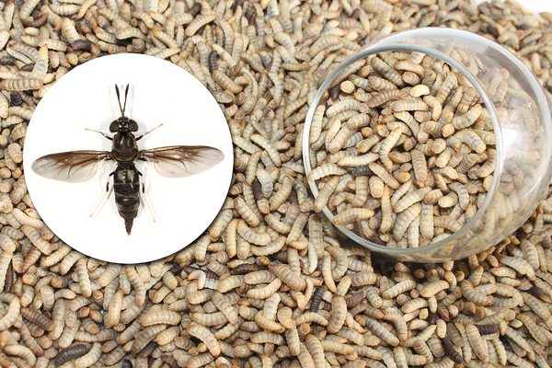
Recently, there are various studies regarding the use of insects as feed components for livestock, this insect is called Black Soldier Fly. Black Soldier Fly is from Hermetia Illucens Species native to tropical regions, whereby they were able to grow on organic waste such as agricultural waste, food industry waste, kitchen waste, and the like. The adult Black soldier fly has a maximum length of 20mm wherein they do not have a mouth to feed like the common fly that can see in households. So, once the BSF achieved the adult phase they do not come nor attract fresh organic matter. Therefore, they do not transmit any diseases whereof has a minimum of 5 days and a maximum of 8 days to live, throughout such period they mate, lay eggs, then hatch for 4 days. Female BSF can lay a minimum of 200 and a maximum of 700 eggs, but 70% to 80% have a chance to live and become larvae (BSFL) depending on the environment. The successful larvae will fall into the rock layer where food is stocked, this food will be the larvae' source of life until such become pupae. Thus, this larvae phase is the most vital since in this period they need to collect adequate nutrition to survive in their next phase of life. Whereby, the larvae phase is used in waste management because they were about to eat for two (2) weeks, before turning to the next phase which is the pupae phase. The pupae phase is the stage where it can be used in livestock feeding and this stage takes around two weeks before becoming completely adult (Spinelli et al., 2019). Because, BSFL has high amino acids, protein, anti-bacterial, and probiotic components (Novandri B, et al., 2017), thus various studies show the potential benefits of BSFL in livestock production as a promising alternative food (Astuti & Wiryawan, 2022).
Source: Chia SY, Tanga CM, Khamis FM, Mohamed SA, Salifu D, et al. (2018)

Table 1. DEVELOPMENT OF BLACK SOLDIER FLY (BSF)
Actual Stage | Description
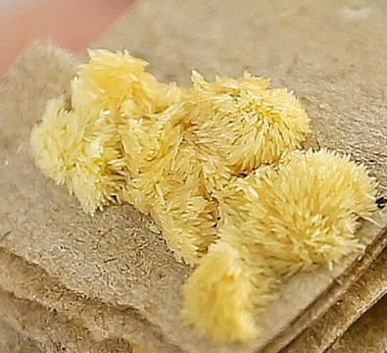 | The eggs of BSF adults. It has a golden yellow color, unlike the normal eggs of houseflies. These eggs will hatch in 3-4 days
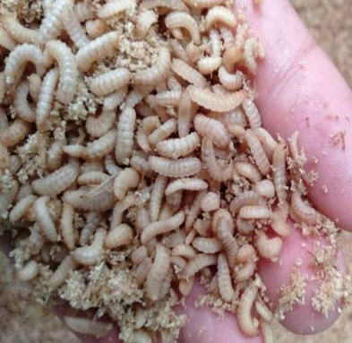 | 6 days old BSF larva. After the hatching of eggs, they will become larvae and start to eat biowaste.
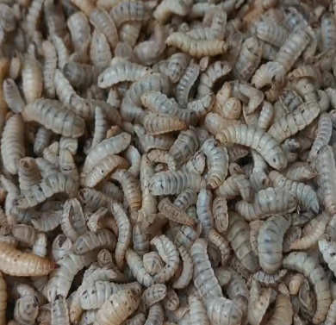 | 12-15 days old BSF larva. This stage is where the ideal stage for harvesting. Its body size is full length and width. More often in this stage, they begin reducing or slowing down in consuming food.
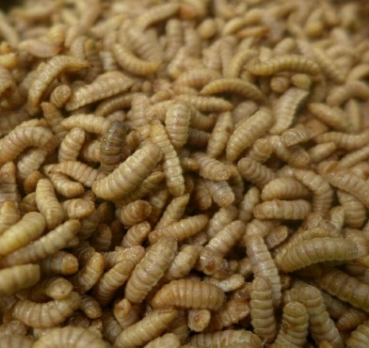 | This is the 22 to 28 days old BSFL, wherein its color becomes darker and its skin is thicker and a little bit rough. This stage started to crawl out into the biopond and look for a darker and more distant location.
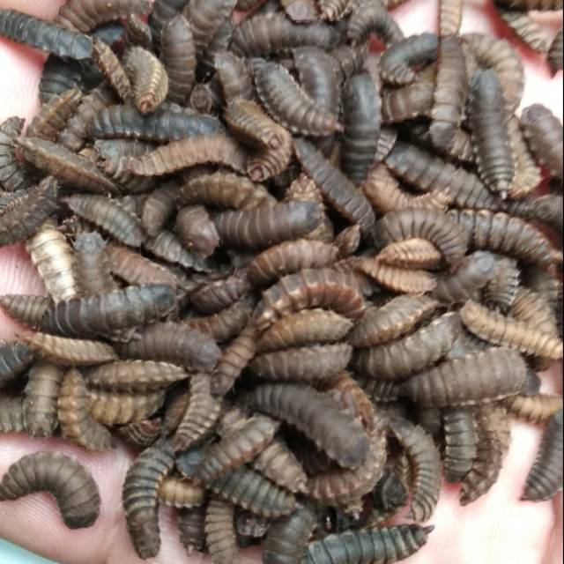 | This is the 34-36 days old pupa, which is the final stage before it will become a BSF adult. This stage is more useful in feed meal operations.
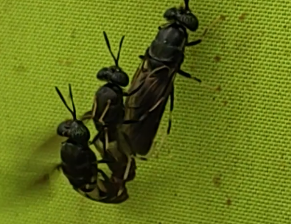 | After the pupae stage, its shells start to remove from its body, this cocoon shell of pupae is called chitosan, the perfect ingredient for feed meals. Thereafter, will turn to fly. And once become fl, they will male and female will mate, then after 8 days they will automatically die.  This image is the 2-3 days old BSF adult wherein the actual mating of male and female BSF is happening.

REVIEW OF RELATED LITERATURE

According to Astuti and Wiryawan (2022), Black Soldier Fly larvae has the potential elements to become a byproduct of milk, lactic Acid Bateria for probiotic, creep feeds, and fattening ration for ruminants. Because the result of their study shows that the utilization of BSF larvae and commercial milk has a similar effect on goat kids' performance, physiological, and hematological levels without changing the weight and blood profiles thereof. Where in fact, Osongo et al., (2018) state that several animal husbandry business failures are due to high feed costs offered by the market. Because the most expensive component needed by animals is the protein that can acquire in soybean and fish meal (SMF). The result of the experimental study shows that SMF which is costly can be replaced by BSF wherein achieved the full potential source of protein with no adverse effect after replacement. However, the study of Loon et al., (2017), suggests that the replacement using traditional feedstuff for animals shall only be partial although the study reveals that BSF larvae contain high nutrients level there should be a further study that explains and validate the nutrients composition, the consequences, significantly the detailed process that entails the digestibility and performance effectiveness of BSF larvae because the complete replacement can reduce the performance of animals due to high-fat and ash content including the challenges regarding insufficient details on BSF adult phase.
According to da Silva and Hesselberg (2020), BSF technology can resolve the existing problems regarding poor waste control and management compared to the existing way of composting, at the same time can be consumed by animals because it has a good source of protein. Romano et al., (2021) demonstrate how thrown spent coffee grounds and the dough can be used to feed BSF larvae whereby justified after the opening of the larvae’s bodies to see the components of nutrients therein, it reveals that BSF larvae fed on ground coffee have highly fatty acids whereas BSF larvae fed dough have high amino acids. While on the frass it has high nitrogen, potassium, and phosphorous. Therefore, the study concludes that BSF larvae can improve animal production and agricultural farming production because the prepupae can be fed to animals while the frass after harvesting the prepupae can be used as organic fertilizer.
BSFL is known as an effective decomposer of biowaste which also serves to increase economic benefit because it is cost-effective to use BSFL in animal husbandry businesses compare with high-cost feed meal as such can be also a great income generator (Osuga et. al., 2018). Wherein supported by two researchers Joly and Nikeima (2019), that the BSFL business is promising particularly in biowaste market value. On the contrary statement by Druckman et al. (2021), the generating income from BSFL production in manufacturing dried BSFL is denoted as not profitable because of the operating cost. Whereas, in BSFL live selling offers greatly profitable and promising margins. In addition, according to Salam et al., (2022), one factor in BSF technology production that needs to be considered is humidity and temperature because BSFL is extremely sensitive which can affect its utilization. Although its egg can tolerate high temperatures from 15ºC to 47ºC in the hatching process but once these eggs become larvae it starts to also become sensitive and the development of each phase/cycle varies significantly due to temperature and humidity. Certain studies by Tomberlin et al.(2009) and Barry (2004) concluded that temperature and humidity affect the cycle of these species in which the most suitable temperature is range from 27.5 ºC to 37.5ºC while relative humidity is at 60%. Whereas, According to Booth and Sheppard (1984) and Holmes (2010), the perfect temperature is only at 27ºC and 60% humidity because there is a positive correlation between mortality rate and utilization. In addition, Adler et al. (2009), concluded that the temperature and the development of BSF have a positive correlation, BSFL has a short life span and below average size adults when the temperature in the rearing facility is between 30ºC to 36ºC unlike the BSF in 27ºC to 30ºC. And so, optimum production is constantly affected (Salifu D, et al., 2018).

SIGNIFICANCE OF THE STUDY

This special project will be of great significance to the following:
To the Researcher
This case study will be of great benefit to the researcher in terms of increasing knowledge and awareness of this kind of waste management technology, appreciating the natural process of decomposition in biodegradable waste including kitchen waste from households and restaurants, food waste from manufacturing, and the like.
To the Students and Future Researchers
This case study will be of great benefit to the students as well as to future researchers in providing additional information about the advantages of utilizing black soldier fly to effective management the biowaste that inspires them to generate new ideas on how to address environmental issues. Likewise, it will serve as their guide and reference for advanced research and future project study.
To the Farm Owner/Entity
This case study will be of great benefit to a business entity operating livestock production whereby will serve as basic guidelines in utilizing the black soldier fly technology to decrease the operating cost for livestock feeding.
To the Community
This case study will be of great significance to the community that increases economic progress in terms of employed citizens operating livestock production, decreases livestock price because of enough supply of livestock in the market, and also the health benefits to the community that adapts the environmental awareness to use organic and eco-friendly approaches in managing biodegradable waste.
To the Government
The study will give additional revenue for the government through the help of taxes coming from the livestock production entity and to the employee of the business, it would increase the number of employed citizens in providing jobs. Whereas, increasing their knowledge and idea about the environmental benefits of black soldier fly technology to manage effectively the biowaste generated by the local communities.
To the Food Manufacturing
This case study will be of great significance to food manufacturing industries that produce bulk leftover, defective, expired, and out of specification as declared waste by the organization as to such effective waste management, the organization in partnership with the farm entity employing black soldier fly technology can help to effectively manage those bulk waste.
To the UPOU Library
This case study will be an additional reference for future researchers as related works to black soldier fly technology engaging in environmental responsiveness in dealing with waste management and livestock production in utilizing BSF larvae.

OBJECTIVES OF THE STUDY

- To be able to assess the utilization of Black Soldier Fly Technology in livestock production;
- To determine the utilization of Black Soldier Fly Technology in biowaste processing.

SCOPE AND DELIMITATION OF THE STUDY

This study shall only cover the assessment of Black Soldier Fly utilization in livestock production and in biowaste processing on a farm. Whereof, actual experiments including testing are excluded herein. Data from testing laboratories that demonstrate the evidence of conformity and usefulness of BSF are from the owner and not from the researcher's accord. Taking any videos related to processes is not permissible as agreed by both parties, this is to protect the integrity of the owner’s rights. Whereas, taking pictures and videos related to the BSF life cycle is permissible.

DESCRIPTION OF THE STUDY AREA

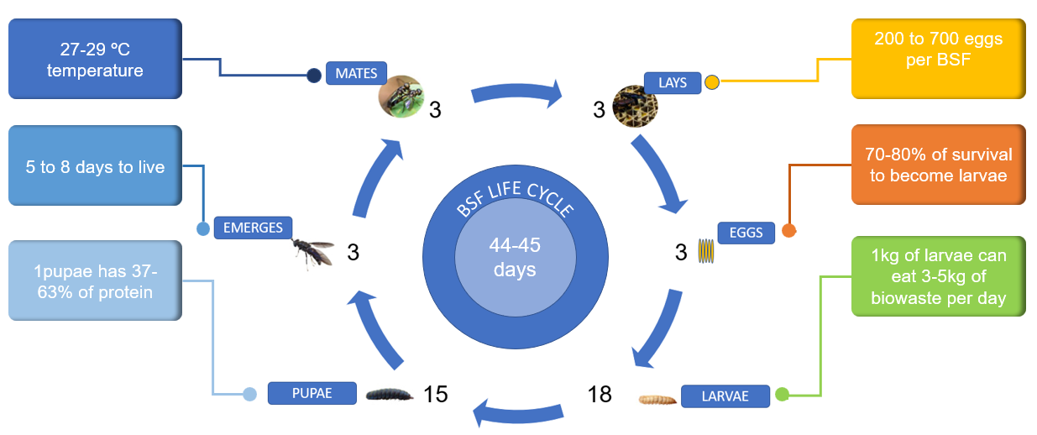
1.1 Life Cycle Assessment and equivalent utilization
Figure 2. The Phases of the Black Soldier Fly (Dickies, et al., 2017)
BSF has 44 to 45 days to complete its life cycle. Wherein, 1 BSF can lay eggs of more than 450 based on average computation. Whereas, 1 gram of BSF eggs is equivalent to 3000 based on cluster count. However, from that cluster, 70 to 80% have a chance to become larvae because of temperature variability. After 3 to 5 days, once the egg becomes larvae. Furthermore, larvae aged 5 to 28 days are very useful in waste management since their purpose is to eat and stock nourishment for their next cycle. Considering that 1 kilogram of BSF larvae can eat 3 to 5 kilograms of biowaste per day on average based on the identified classification of the biowaste. This means that the softer the biowaste the faster that BSF larvae can eat and dissolve it. In addition, in between larvae and pupae phases whereof aged 17 to 36 days are very useful in livestock production, they can be eaten as live for chicken and fish but for quadrupeds or ruminants animals. After 36 days, it becomes an adult. The BSF adult has 6 legs, two wings, and without a stinger or mouth. Within 5 to 8 days of being an adult that is the phase where mating and hatching of eggs happened. After such period, the adult BSF will automatically die and where thereafter be collected and used as part of the ingredients for feedstuffs and oil extraction. (Dickie et al., 2017).
However, at the place where the study was conducted, in 1 cluster there are 3000 to 5000 eggs, whereof there is a 30 to 40% mortality rate. Therefore, there is only a 60-70% chance from that cluster to become larvae. The successful larvae will be sent or transferred to a biopond to eat the biowaste for 2 weeks. The staff checks the pH level of their food regularly because pH level is very important to consider since the components of their foods that contain sodium chloride and alcohol are not allowed. Thereafter another 2 weeks, the larvae become pupa and transfer to a dark room and after 2 weeks again, these pupae emerge as adults and mate for 2 days thereafter laying eggs for 6 to 7 days. Once the eggs are already hatched, the 2 days old larvae will be transferred to a biopond. There are bioponds allocated for feed meals where there are classifications in feeding, it can be eaten alive, or it can be eaten as boiled, or steamed for 4 to 5 secs and it can also be mixed with traditional feedstuff or can be dried and ground thereafter served alone as a protein because 1 BSF larvae have an equivalent of 40.31% protein.
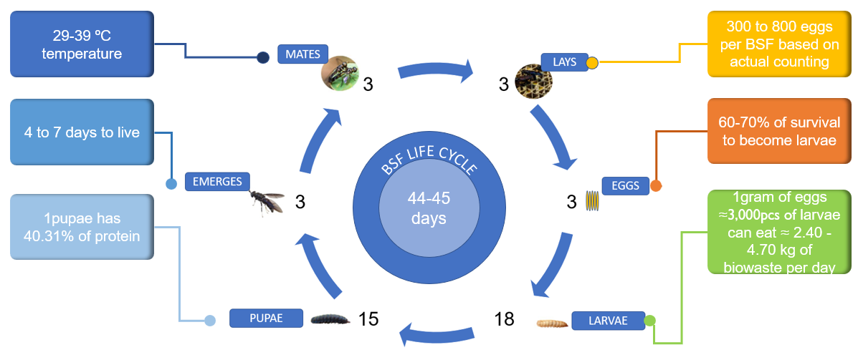
Figure 3. The Phases of the Black Soldier Fly and their development Based on Actual Investigation

1.2 Impact of Environment and Temperature on BSF Life Cycle
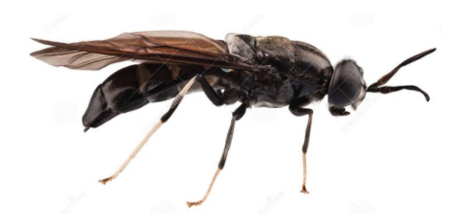
This is the actual appearance of BSF adults, Wherein temperature is very essential as the larvae successfully become adults. The ideal temperature to prolong their existence is 27ºC and If the temperature increases to 30-36 ºC it affects their rearing development and decreases their survival (Park, 2016).
Figure 4 BSF Adult Source: Park H.,( 2016)
Where in fact, the development in rearing will increase the development of BSF by up to 10%, meaning it will prolong their life by 2 to 3 days (Tomberlin, 2022). Moreover, as supplemental evidence from Park’s paper (2016), BSF is very sensitive to temperature thus he concludes that humidity is also one factor in BSF sensitivity, which he added that lower humidity will cause a high mortality rate in the production of eggs. But, if the humidity is at 70%, there is an additional 2 to 3 days extension to the life of BSF adults.
Whereas, the location where the data was collected reveals that the temperature is quite different. Instead of 27-30 ºC, the farm utilizes the temperature range of 29-39ºC but not more than 45 ºC depending on the weather. As the owner stated that at 45 ºC the larvae started to crawl and leave their food. As a result, the 5 to 7 days old larvae in the biopond will die, but the 12 to 15 days old start to crawl to find a darker place and thereafter becomes a pupa. But, this is not the expected development, meaning it will decrease the period when the BSF larvae get their nutrients from the feeding period wherein eventually necessary for their adult phase, particularly in their egg production. In the paper written by Park (2016), BSF adults need mists as much as possible droplets water. But, on the farm where the study was conducted, the BSF rearing facility covers by a net and has plants inside of it that create more moisture in the morning and natural water from the mist.

1.3 Study Area and Source of Biowaste
The study was conducted on one of the Farms in Calauan Laguna having 60,000 sqm (6 ha) which was originally developed as a small poultry farm wherein the owner utilizes the BSF larvae for alternative feedstuff and animal manure management. After several years, the owner decided to produce its own BSF production and later own ended up publicizing the BSF for waste management and alternative feeds for birds, chickens, fish, and pigs.
For waste management, the farm is collecting biowaste from various well-recognized food manufacturing plants in Laguna such as doughs, milk, processed bread, tofu, soya, vegetables, gelatin, used coffee grounds, and meats including processed meats. Moreover, the farm is also handling kitchen waste and market waste collection from LGU Laguna.
Around 10 to 30 tons of biowaste has been collected by the farm every day. The collected biowaste has been stocked in the available open space area and then manually lifted by farmer staff thereafter transfer to the grinder machine, particularly meats, processed meats, and other spoiled kitchen waste, commercial waste, and market waste wherein connected to each biopond, consisting of 1,500,000 BSF larvae each pond. This process also helps the BSF larvae easily ingest the food.

1.3 Impact of Biowaste Classification on BSF Feeding

The owner classified four types of feeding compositions for BSF larvae from the collected biowaste, established in the table below.
Table 2. Biowaste Classification on BSF Feeding
Biowaste Classification | Components
F1 | Soya, tofu, gelatin, and milk
F2 | Vegetables, kitchen waste, doughs, bread, and fruits,
F3 | 50% of F1 and F2 and 50% of F4
F4 | Meat

These four identified classifications of biowaste are separated into four bioponds with an average area of 50 sqm each, and each bioponds contain 1,500,000 larvae. This classification may determine the effective utilization of BSF larvae in biowaste management depending on the biowaste texture and components. This may also be a basis for the nutritional level assessment for BSF larvae that can be useful as alternative feed meals to fish and chicken, particularly for livestock production.

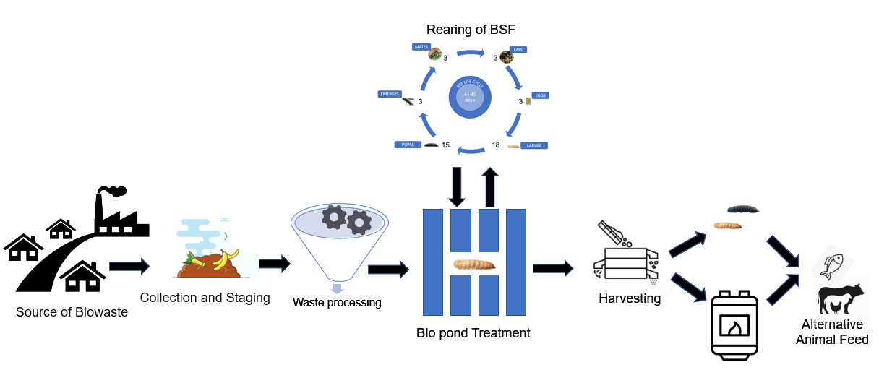
1.4 Biowaste Processing
Figure 5. Complete Biowaste Processing and Black Soldier Fly Production
The source of biowaste is from food manufacturing, selected residential, commercial, and stores and markets. The collected biowaste will be stored in a vacant space on the farm, thereafter manually transfer to the grinding machine for F2 to F4 classification, for F1 it will be automatically transferred to biopond treatment. Upon grinding of F2 to F4, there should be an allocated amount of water to be added before transferring to biopond treatment. All the larvae from the rearing facility will be transferred to a biopond, after 15 days to 17 days the larvae that reach the maximum and or allowable size will be harvested. The harvested larvae are available as alternative feed meals for fish, chicken, and birds, particularly in livestock production. While 60% to 70% of BSF larvae from the biopond will be transferred to rearing facilities to continuously emerge the BSF population.

METHODOLOGY

The researcher would like to use the exploratory case study method as the researcher will assess the utilization of Black Soldier Fly Technology in livestock production in consideration also the determination of the biowaste processing using the Black Soldier Fly Technology including its effectiveness. Whereof, the researcher will examine if the number of Black Soldier Fly is sufficient and doable to utilize here in the Philippines as an alternative food in livestock employing the Life Cycle Assessment (LCA) method as well as its significance to biowaste management.

RESULTS

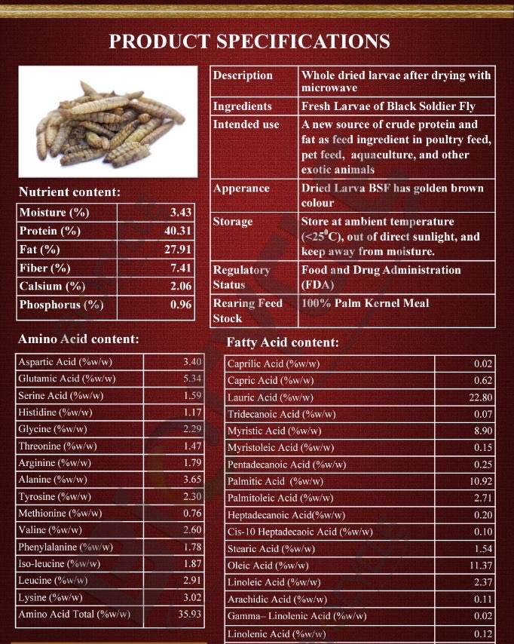
1.1 Effectiveness of BSF in livestock production

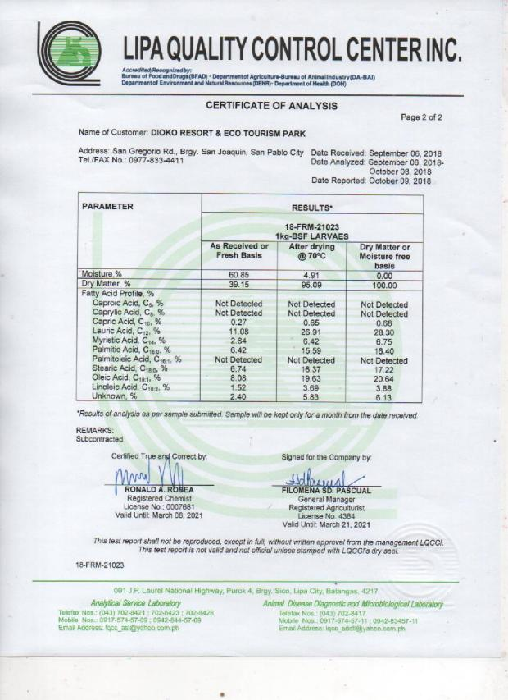

Figure 6. BSF larvae’s effectiveness based on Certificate of Analyses Outcome

1.2 Effectiveness of BSF in Biowaste Management

Figure 7.BSF utilization in biowaste processing
Table 3. Price Comparison Between Black Soldier Fly Larvae and Traditional Feed Meal

BSF Larvae | Price/KG | Traditional Feed Meal | Price/KG
Live BSF Larvae | P28 | Hog Pellet | P39
BSF Pellet 100% | P37 | Integra | P51
BSF premix 50% | P35 | Grower | P47
 |  | Pre-Starter | P64

The increasing prices of meat protein in the Philippines specifically in the Manila area are mainly because there is also a high price of feed meals offered by the market particularly the price of corn and soybean wherein 60% to 80% is a major source of protein (Miraflor, 2021).
Recently, the Department of Agriculture (DA) rolls out plans regarding animal feed due to the continuous increase of feed prices in the market (Arriesgado, 2023). Whereas, few farmers know about BSF larvae and utilize as an alternative feed meal.
The prices of BSF larvae according to their classification were provided by the farm owner and available at the farm.

ANALYSIS AND DISCUSSION

After three (3) weeks of exploration, the researcher assessed the utilization of Black Soldier Fly Technology in livestock production and biowaste processing wherein the effectiveness of BSF larvae in livestock production, is certainly effective based on the certificate of analysis (COA) and laboratory test result regarding protein and other significant minerals. Moreover, it is proven because the farm utilizes this technology for their livestock for almost four years. According to the owner, the farm started to utilize this technology during the covid 19 pandemic primarily to support their own needs and other necessities. This has a positive result because pigs gain weight in an early stage based on their selling point.
Whereas the utilization of Black Soldier Fly Technology in biowaste processing has been certainly effective [see fig.6]. The computation is based on the life cycle assessment and the average number of BSF larvae produces per 1 BSF female. Based on related literature, 1 female black soldier fly can lay 200 to 700 eggs, whereas on the Pilot farm, there are 300 to 800 eggs per BSF on average, but the maximum number may vary depending on the size of the BSF female adults which the maximum size can reach up to 1500 eggs. Wherein 1 gram of eggs is equivalent to 3000 to 5000 larvae depending on the temperature since the Philippines has a tropical temperature it is important to maintain the ideal temperatures because if it is too hot the larvae will crawl away from the food and the mortality rate will be more than expected to 30%, so if the farm expected to have 300 to 800 eggs per BSF, where in average it is equivalent 550, thereafter less the 30% of mortality rate, then the output is only 385 eggs in total. while if it is too cold, larvae will be stocked at the bottom of the foods or substrates thereafter resulting in a smaller size of larvae than expected of a maximum of 12mm. Wherein, according to Dortmans et al. (2017), the effective temperature is between the range of 24ºC to 30ºC. While 27ºC according to Park (2016). Whereas on the pilot farm where the study was conducted, the allowable temperature sets by the owner is between 27ºC to 35ºC provided by certain conditions that the biopond and rearing facilities have proper covers and more water concentration significantly in the rearing facilities that require a humid environment and proper covers because pupae phase needs a dark place, dry and warm places to successfully emerge from its pupae shell to become adult BSF. However, due to tropical conditions here in the Philippines, other environmental factors, and financial constraints, the temperature that has been applied on the farm is between 29ºC to 39ºC but not more than 45 ºC. Additionally, pH level is also significant because if the food contains Salt, BSF will die in just 3 to 5 seconds.
Moreover, when it comes to the utilization of BSF in biowaste management, the researcher computes based on the average output of BSF larvae considering the mortality rate of 20% to 30%, as a result of the computation, 1 gram of BSF eggs equivalent to 3000 larvae on average. Therefore 1 kg of BSF eggs is equivalent to 3,000,000 larvae. And, these 3,000,000 larvae can eat or consume 111. 76 kg of biowaste per day. Whereas, per year the technology can consume 18,774. 84 kg. Whereof, the farm facilitates 4 biopond and each biopond has 750,000 to 1,500,000 larvae which can consume around 89.40 to 167.87 kg of biowaste per day. However, 10 to 30 tons of biowaste has been collected by the farm every day therefore there is an insufficient number of larvae that can consume those tons of biowaste from different companies.
In fact, 25% of the total production will be going to the feed meal operation, whereas 50% will be transferred to the rearing facility to multiply the number of BSF, and the remaining 25% be allocated for selling live larvae.

RECOMMENDATION AND CONCLUSION

After exploration, based on the collected data and computation of the researcher, the farm has an insufficient rearing facility to increase the number of BSF population and cater the three operations employed therein which are biowaste processing, selling of live BSF larvae, and feed meal for livestock production. Though there has been an overflowing of biowaste every day available to feed the BSF Larvae and gets its maximum size and nutritional level that can be used as certain. However, because of the tropical temperature in the Philippines, it affects the survival rate of BSF larvae. Since the pilot farm employs 29ºC - 39ºC, only 60% to 70% of BSF larvae have a chance to survive per instar. Therefore, BSF larvae continuously decrease their number before the harvesting period. Moreover, other equipment utilized by the farm such as rake, biopond, and bins also affects the mortality rate of BSF. Significantly, the storage facility of biowaste collected by the farm is not enough due to an unforeseen number of tons of biowaste delivered from different food industries in the Laguna area versus the available number of BSF larvae on the farm. Therefore, there has a scarcity of BSF larvae on the farm to successfully consume all the collected tons of biowaste from different industries. Finally, because there has an overflowing supply of biowaste; the farm employs fermentation and grinding of food processing to easily digest the biowaste by the BSF larvae, particularly meat, dough, and other hard food. However, fermented food also affects the mortality rate due to excessive pH levels since there are no specific guidelines employed by the farm regarding shelf life.

THEREFORE, the following recommendations are promulgated to utilize effectively the BSF Technology in the pilot farm, whereof:
- An effective facility shall be necessary to maximize the optimum benefits of Black Soldier Fly Technology to biowaste processing and use this BSF technology as an alternative feed meal for livestock production. Facility means the building of the biopond, the equipment used by the farm in the biopond specifically the rake and bins, and the innovation of the rearing facility concerning the temperature and the humidity;
- It is recommended that the pilot farm shall decrease the temperature from 29ºC - 39ºC to 27ºC - 35ºC in the rearing facility, this is to decrease the mortality rate of BSF larvae;
- It is recommended that a regular schedule for monitoring the temperature in the rearing facility shall be employed to evaluate effectively what is being necessary to continually improve the rearing development of BSF larvae; and
- It is recommended that the fermented biowaste shall have a specific shelf life and proper storage to decrease the mortality rate of BSF larvae due to excessive pH levels.

REFERENCES

- Astuti, D. A., & Wiryawan, K. G. (2022). Black soldier fly as feed ingredient for ruminants. Animal Bioscience, 35(2), 356. https://doi.org/10.5713/ab.21.0460
- Barragan-Fonseca, K. B., Dicke, M., & van Loon, J. J. (2017). Nutritional value of the black soldier fly (Hermetia illucens L.) and its suitability as animal feed–a review. Journal of Insects as Food and Feed, 3(2), 105-120. https://doi.org/10.3920/JIFF2016.0055
- Cervantes, F.M. (2022). A gri sector needs more public, private investment: solon. https://www.pna.gov.ph/articles/1166623
- Chia, S. Y., Tanga, C. M., Khamis, F. M., Mohamed, S. A., Salifu, D., Sevgan, S., ... & Ekesi, S. (2018). Threshold temperatures and thermal requirements of black soldier fly Hermetia illucens: Implications for mass production. PloS one, 13(11), e0206097. https://doi.org/10.1371/journal.pone.0206097
- Da Silva, G. D. P., & Hesselberg, T. (2020). A review of the use of black soldier fly larvae, Hermetia illucens (Diptera: Stratiomyidae), to compost organic waste in tropical regions. Neotropical entomology, 49(2), 151-162. https://doi.org/10.1007/s13744-019-00719-z
- Dortmans, B. M. A., Diener, S., Verstappen, B. M., & Zurbrügg, C. (2017). Black soldier fly biowaste processing-a step-by-step guide Eawag: Swiss Federal Institute of Aquatic Science and Technology. Dübendorf, Switzerland, 100.
- Filimonau, V., Algboory, H., Mohammed, N. K., Kadum, H., Qasem, J. M., & Muhialdin, B. J. (2023). Food waste and its management in the foodservice sector of a developing economy: An exploratory and preliminary study of a sample of restaurants in Iraq. Tourism Management Perspectives, 45, 101048. https://doi.org/10.1016/j.tmp.2022.101048
- Fischer, H., Romano, N., & Sinha, A. K. (2021). Conversion of spent coffee and donuts by black soldier fly (Hermetia illucens) larvae into potential resources for animal and plant farming. Insects, 12(4), 332. https://doi.org/10.3390/insects12040332
- Harnden, L. M., & Tomberlin, J. K. (2016). Effects of temperature and diet on black soldier fly, Hermetia illucens (L.)(Diptera: Stratiomyidae), development. Forensic Science International, 266, 109-116. https://doi.org/10.1016/j.forsciint.2016.05.007.
- Jayanegara, A., Yantina, N., Novandri, B., Laconi, E. B., Nahrowi, N., & Ridla, M. (2017). Evaluation of some insects as potential feed ingredients for ruminants: Chemical composition, in vitro rumen fermentation and methane emissions. Journal of Indonesian Tropical Animal Agriculture, 42(4), 247-254. https://doi.org/10.14710/jitaa.42.4.247-254
- Joly, G., & Nikiema, J. (2019). Global experiences on waste processing with black soldier fly (Hermetia illucens): from technology to business (Vol. 16). Iwmi.
- Khan, I., Chowdhury, S., & Techato, K. (2022). Waste to energy in developing countries—a rapid review: opportunities, challenges, and policies in selected countries of Sub-Saharan Africa and south Asia towards sustainability. Sustainability, 14(7),3740. https://doi.org/10.1016/j.wasman.2008.08.031
- Ominski, K., McAllister, T., Stanford, K., Mengistu, G., Kebebe, E. G., Omonijo, F., ... & Wittenberg, K. (2021). Utilization of by-products and food waste in livestock production systems: A Canadian perspective. Animal Frontiers, 11(2), 55-63. https://doi.org/10.1093/af/vfab004
- Onsongo, V. O., Osuga, I. M., Gachuiri, C. K., Wachira, A. M., Miano, D. M., Tanga, C. M., ... & Fiaboe, K. K. M. (2018). Insects for income generation through animal feed: effect of dietary replacement of soybean and fish meal with black soldier fly meal on broiler growth and economic performance. Journal of economic entomology, 111(4), 1966-1973. https://doi.org/10.1093/jee/toy118
- Premakumara, D. G. J., Menikpura, S. N. M., Singh, R. K., Hengesbaugh, M., Magalang, A. A., Ildefonso, E. T., ... & Silva, L. C. (2018). Reduction of greenhouse gases (GHGs) and short-lived climate pollutants (SLCPs) from municipal solid waste management (MSWM) in the Philippines: Rapid review and assessment. Waste Management, 80, 397-405. https://doi.org/10.1016/j.wasman.2018.09.036
- Spinelli, R. O. S. A. N. G. E. L. A., Neri, P., Pini, M., Barbi, S., Montorsi, M. O. N. I. A., & Ferrari, A. M. (2019). Using black soldier flies (Hermetia illucens) to bioconvert waste from the livestock production chain: A life cycle assessment case study. WIT Trans. Ecol. Environ, 231, 47-58.
- Suckling, J., Druckman, A., Small, R., Cecelja, F., & Bussemaker, M. (2021). Supply chain optimization and analysis of Hermetia illucens (black soldier fly) bioconversion of surplus foodstuffs. Journal of Cleaner Production, 321, 128711. https://doi.org/10.1016/j.jclepro.2021.128711.
- Tomberlin, J. K., Adler, P. H., & Myers, H. M. (2009). Development of the black soldier fly (Diptera: Stratiomyidae) in relation to temperature. Environmental entomology, 38(3), 930-934 https://doi.org/10.1603/022.038.0347
- Wena, C. (2022). Food wasted by the tons while millions of Filipinos go hungry. https://news.abs-cbn.com/news/10/04/22/tons-of-food-wasted-as-millions-of-filipinos-go-hungry.
- CWS. (2022). Global Waste Statistics – 2022. https://cheapawasteskips.com.au/global-waste-statistics-2022/
- Alcimed. (2022). 3 ways Asia is cutting down food loss and food waste along the value chain. Retrieved from https://www.google.com/url?sa=t&rct=j&q=&esrc=s&source=web&cd=&cad=rja&uact=8&ved=2ahUKEwj9mO37ucL9AhUysVYBHXMfA7MQFnoECCAQAw&url=https%3A%2F%2Fwww.alcimed.com%2Fen%2Falcim-articles%2F3-ways-asia-is-cutting-down-food-loss-and-food-waste-along-the-value-chain%2F%23%3A~%3Atext%3DHowever%252C%2520over%252050%2525%2520of%2520global%2520food%2520waste%2520comes%2520from%2520Asia.&usg=AOvVaw2BPfOnoo9kACI2yAdnWxw0

- Miraflor. (2021). Rising prices of animal feed ingredients to push meat prices higher. Retrieved from https://mb.com.ph/2021/02/22/rising-prices-of-animal-feed-ingredients-to-push-meat-prices-higher/.

ANNEXES

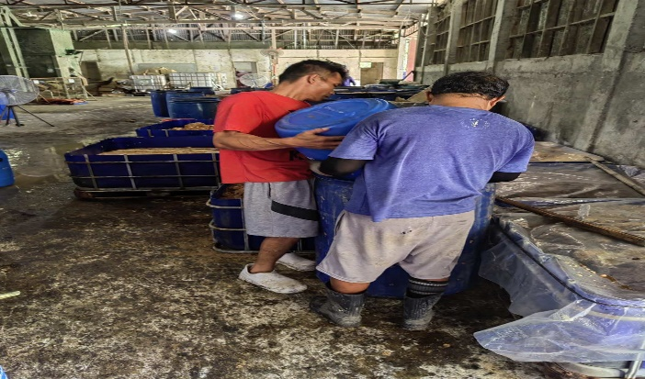
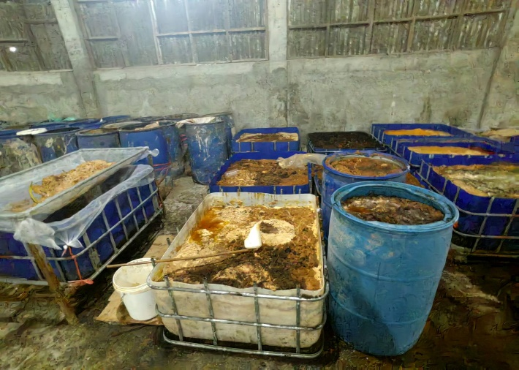
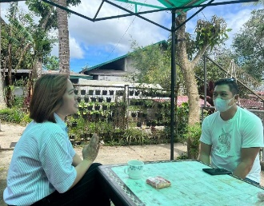

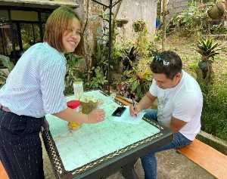

Annex A. Evidence of Plant Visit
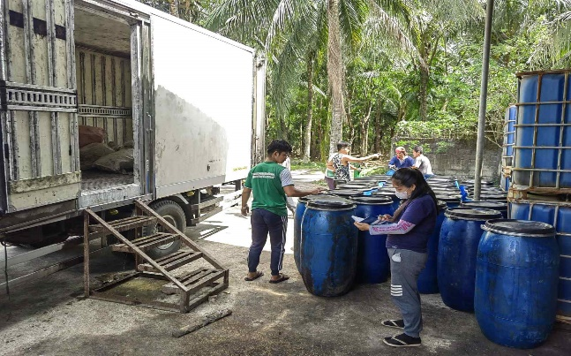

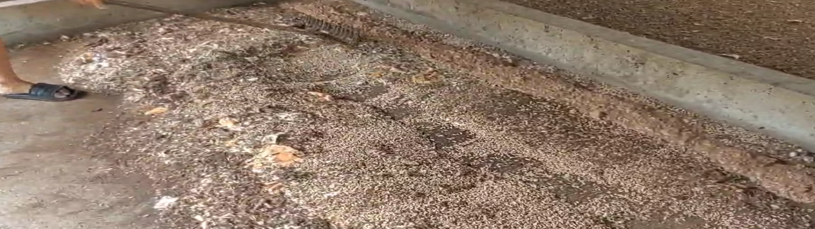

Annex B. Supplemental link for additional evidence
https://drive.google.com/drive/folders/1lYYlsDiC3MY2dlvfmfKHQOlBQBPyA9ca?usp=share_link

