

UNIVERSITY OF THE PHILIPPINES

OPEN UNIVERSITY

Master of Information Systems

JASMINE LICUDINE NAVALTA

VEHICLE MONITORING SYSTEM WITH QR CODE FOR THE
DON MARIANO MARCOS MEMORIAL STATE UNIVERSITY
NORTH LA UNION CAMPUS
BACNOTAN, LA UNION

Thesis/Dissertation Adviser:
PROF. MARI ANJELI L. CRISANTO
Faculty of Information and Communication Studies

Date of Submission
10 January 2022

Permission is given for the Following people to have access to this thesis/dissertation:
Available to the general public | Yes/No
Available only after consultation with author/thesis/dissertation adviser | Yes/No
Available only to those bound by confidentiality agreement | Yes/No

Student’s Signature:
Signature of Thesis/Dissertation/Adviser:

“I hereby grant the University of the Philippines a non-exclusive, worldwide, royalty-free license to reproduce, publish and publicly distribute copies of this thesis or dissertation in whatever form subject to the provisions of applicable laws, the provisions of the UP IRR policy and any contractual obligations, as well as more specific permission marking on the Title Page.”

“Specifically, I grant the following rights to the University:

- To upload a copy of the work in the theses database of the college/school/institute/ department and in any other databases available on the public internet;
- To publish the work in the college/school/institute /department journal, both in print and electronic or digital format and online; and
- To give open access to above-mentioned work, thus allowing “fair use” of the work in accordance with the provisions of the Intellectual Property Code of the Philippines (Republic Act No. 8293), especially for teaching, scholarly and research purposes.”

_________________________________
Student Name over Signature and Date

© 2021 By Jasmine Licudine Navalta

This Special Project titled

Vehicle Monitoring System with QR Code for the Don Mariano Marcos Memorial State University- North La Union Campus Bacnotan, La Union

is hereby accepted by the Faculty of Information and Communication Studies in partial fulfillment of the requirements for the Master of Information Systems.

__________________________
Adviser
____________
Date

__________________________
Program Chair
____________
Date

__________________________
Dean
Faculty of Information and
Communication Studies
____________
Date

ABSTRACT

This study developed a Vehicle Monitoring System Using QR Code to help monitor the vehicles entering and leaving the campus in order to ensure the health and safety of the employees/workers/students at Don Mariano Marcos Memorial State University (DMMMSU) - North La Union Campus (NLUC).

Specifically, it aimed to (a) determine the socio-demographic profile of the respondents as to age and type of respondent; and (b) assess the level of acceptability of the Vehicle Monitoring System as to functional suitability, performance efficiency, usability, reliability, security and portability

The study used descriptive and developmental research methods, with survey questionnaires as the primary data collection instruments. Twenty (20) employees and twenty (20) security guards were among the survey's participants.

ACKNOWLEDGMENTS

The author genuinely acknowledges and expresses her deepest thanks to all those who, in one way or another, made possible the accomplishment of this study, particularly the following:
Prof. Mari Anjeli L. Crisanto, her ever supportive thesis adviser, for sharing her time, expertise and encouragement for the success of the study.
Dr. Junifer Rey E. Tabafunda, Chancellor of the North La Union Campus, who permitted the conduct of the research.
Mr. Prince Jun Damasco, head of the security unit, for providing the needed information for the study.
Prof. Joan S. Valdez, her compassionate chairperson, for pushing the author to continue and strive hard to finish her thesis.
LHSD Faculty Members, her supportive colleagues in the academe who shared pieces of advice and words of encouragement.
Her loving parents, Mr. Felix Benigno N. Navalta and Mrs. Shalimar L. Navalta, her grandparents Mr. Ronald D. Licudine and Mrs. Juliana R. Licudine, her siblings, Bensh and Shann Jastel, for the moral and financial support, prayers, encouragement, love and inspiration.
Her husband, Mr. Justine Lester L. Ilagan, for his unending support, morally and financially, for his unrelenting motivation and positive uplifting and unconditional love.
Above all, to the Almighty God, who showered her blessings, divine guidance, courage, wisdom and strength during times of struggle, thus fulfilling her cherished dream to finish this undertaking.
To all of them, this book is dedicated.
J.L.N

TABLE OF CONTENTS

Abstract v
Acknowledgments vi
Table of Contents vii
Introduction 1
Review of Existing Alternatives 2
Project Details 5
A. Overview 5
B. Technologies Used 15
Project Assessment 18
A. User Testing 18
B. Security Testing 19
Discussions 20
Conclusion 31
Future Work 33
References 34
Appendices 36

Dedicated to:
The Author’s Family and Fiancé

Chapter I

INTRODUCTION

Statement of the Problem
The Don Mariano Marcos Memorial State University (DMMMSU) has three campuses which are the Mid La Union Campus (MLUC) at San Fernando City, La Union, South La Union Campus (SLUC) at Agoo, La Union and the main campus North La Union Campus (NLUC) at Bacnotan, La Union. With its accessible location for a lot of municipalities nearby, DMMMSU-NLUC is one of the most being sought after schools in La Union, many people shows interest be it for work or academic purposes, with this said, people are going in and out of the campus for a lot of reasons, and as a response to the drastic increase of CoVID-19 cases in the Municipality of Bacnotan. The Don Mariano Marcos Memorial State University (DMMMSU) - North La Union Campus (NLUC), is currently enforcing strict guidelines for who is permitted to enter the campus premises, with one of the several safety protocols being enforced, having to use a log book that asks for the driver's name, address, phone number, and other details.
Background and Objectives of the Project
With the problems stated above, DMMMSU – NLUC requested a system that would help them with the monitoring of all vehicles that would enter and leave the campus. The researcher intended to perform the study in this context in order to raise awareness of the features of the vehicle monitoring system by employing QR codes. As a result, this research is geared toward evidence-based practice using this type of computer system, which will serve as a preference for continuous improvement and work on recommendations on how this type of system can be adapted in Don Mariano Marcos Memorial State University – North La Union Campus.
Significance and Scope of the Project
The developed system is a great tool to help all the stakeholders, security officers, the campus and the University to achieve its mantra “To be a globally competitive University” specifically in offering safety for everyone in the campus. The system will have all security officers of the campus, and some administrative employees as respondents to ensure that the system will be as how they expect it to be and how they expect it to function.

Documentation of Existence and Seriousness of the Problem
DMMMSU-NLUC, uses a traditional manual system using logbook for monitoring and data gathering regarding who comes in and comes out of the campus, which causes problems with: (a) data collection, all of those who wish to enter the campus premises are asked to write their name, address, contact number and their vehicles plate number, this alone causes a traffic jam on the main gate; (b) data retrieval, sometimes take more time than usual since reading of handwritings can be challenging once in a while; (c) Health protocols, since the pandemic began, people try their best not to be in a crowded area they even avoid contact with people, but for the strict implementation to ensure health protocols, they are asked to come out of their vehicle to write their details; and (d.) Security Measures, there are no filed complaints on theft or other serious security issues inside the campus, but one can never be too careful when it comes to safety of all stakeholders of the campus.

Chapter II

REVIEW OF EXISTING ALTERNATIVES

The security team of DMMMSU-NLUC is on their toes in implementing strict measures of traditional ways of logbooks.
Logbooks are there for its purpose, but imagine having all vehicles that are allowed to enter the campus have a unique QR code and all their details be collected and stored on the database with one swipe?
During rush hour, traffic congestion is already a problem at the main gate on campus; what is the cause? The filling out of the logbook with your details upon entry. The developed system would help not only the security team, but also the workers and those who wish to access the campus grounds.
There is no digital technology in the current system, thus the whole process of authenticating the vehicle's credentials is done manually by reviewing physical copies of the paperwork. As a result, the vehicle user will have to carry a physical copy of the documents with him or her everywhere he or she travels. The current system is inefficient, generates traffic congestion, lacks transparency, and is difficult to understand. The method is clearly time-consuming since the whole procedure is done manually and there are at least three papers that need to be examined appropriately. A document's tangible copy may also be tampered with or falsified. If this operation is carried out in congested areas, traffic congestion will result. It will be inconvenient not only for those waiting for their car to be certified, but also for other commuters who have nothing to do with the procedure. The inspecting authority has the power to determine whether the papers are sufficient to verify the vehicle or whether more evidence is required to prove the logbook’s truthfulness. The inspecting authority has the last word on the logbook’s availability or lack thereof, as well as their authenticity, citing technical reasons. It will lead to a loss of faith in the overall process among car users. Then there's the lack of process simplification, since logbooks often include several pages, and when the number of vehicle users requiring their credentials to be validated exceeds the police force's existing human resources, the whole operation may become time consuming.

Chapter III

PROJECT DETAILS
- Overview

The Vehicle Monitoring System, functions as a time stamp database for vehicles entering and going out of the campus, it has real time monitoring functions with instant printable logs. The system allows (1) Super Admin who can add, edit, delete employees profiles, employees with QR Codes are only able to request their logs if needed for alternative attendance records.

Theoretical Framework
The theory anchored in this proposal is the Theory of Diffusion of Innovations put forward by Rogers is based on four factors: innovation communication channel, time and social system. According to Rogers (2003), this diffusion is a process of communication via certain channels between the members of the social system regarding the “new”.
In his theory, Rogers defined „innovation‟ as an idea, an application or an object considered to be new by an individual or organization. An innovation does not have to be a concept or a design that is definitely unknown. It is enough that the individual or organization has not used it before (Berger, 2005). There are five phases in Roger’s model: Knowledge, persuasion, decision, implementation and confirmation.
∙ Knowledge: The individual gets informed about the innovation and its use.
∙ Persuasion: The individual evaluates the positive and negative aspects of the innovation and shapes his/her attitudes accordingly.
∙ Decision: In this phase, the individual decides to accept or reject the innovation.
∙ Implementation: This phase exists if the decision phase is completed positively.
∙ Confirmation: The Individual affirms and strengthens the adoption decision (Orr, 2003).
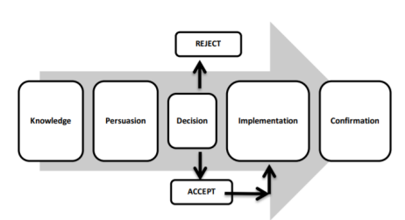Figure 1. The innovation-decision process (Rogers, 1995)

ISO-25000 Standards / ISO 25010
The ISO 25010 quality model is the cornerstone of a product quality evaluation system. The quality model determines which quality characteristics will be taken into account when evaluating the properties of a software product.
The quality of a system is the degree to which the system satisfies the stated and implied needs of its various stakeholders, and thus provides value. Those stakeholders' needs (functional suitability, performance efficiency, usability, reliability, security, maintainability, etc.) are precisely what is represented in the quality model, which categorizes the product quality into characteristics and sub-characteristics.
The product quality model defined in ISO/IEC 25010 comprises the eight quality characteristics shown in the figure:
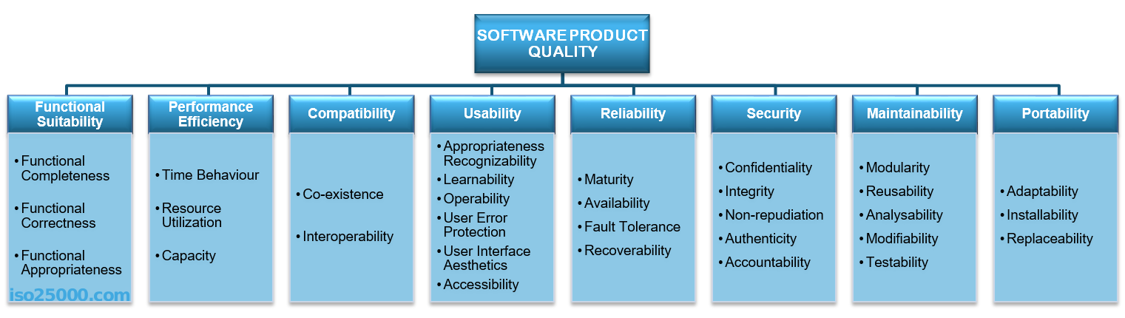

Functional Suitability. This characteristic represents the degree to which a product or system provides functions that meet stated and implied needs when used under specified conditions. This characteristic is composed of the following sub-characteristics:
- Functional completeness - Degree to which the set of functions covers all the specified tasks and user objectives.
- Functional correctness - Degree to which a product or system provides the correct results with the needed degree of precision.
- Functional appropriateness - Degree to which the functions facilitate the accomplishment of specified tasks and objectives.

Performance efficiency. This characteristic represents the performance relative to the amount of resources used under stated conditions. This characteristic is composed of the following sub-characteristics:
- Time behavior - Degree to which the response and processing times and throughput rates of a product or system, when performing its functions, meet requirements.
- Resource utilization - Degree to which the amounts and types of resources used by a product or system, when performing its functions, meet requirements.
- Capacity - Degree to which the maximum limits of a product or system parameter meet requirements.

Compatibility. This characteristic represents the degree to which a product, system or component can exchange information with other products, systems or components, and/or perform its required functions while sharing the same hardware or software environment. This characteristic is composed of the following sub-characteristics:
- Co-existence - Degree to which a product can perform its required functions efficiently while sharing a common environment and resources with other products, without detrimental impact on any other product.
- Interoperability - Degree to which two or more systems, products or components can exchange information and use the information that has been exchanged.

Usability. This characteristic represents the degree to which a product or system can be used by specified users to achieve specified goals with effectiveness, efficiency and satisfaction in a specified context of use. This characteristic is composed of the following sub-characteristics:
- Appropriateness recognizability - Degree to which users can recognize whether a product or system is appropriate for their needs.
- Learnability - Degree to which a product or system can be used by specified users to achieve specified goals of learning to use the product or system with effectiveness, efficiency, freedom from risk and satisfaction in a specified context of use.
- Operability - Degree to which a product or system has attributes that make it easy to operate and control.
- User error protection. Degree to which a system protects users against making errors.
- User interface aesthetics - Degree to which a user interface enables pleasing and satisfying interaction for the user.
- Accessibility - Degree to which a product or system can be used by people with the widest range of characteristics and capabilities to achieve a specified goal in a specified context of use.

Reliability. This characteristic represents the degree to which a system, product or component performs specified functions under specified conditions for a specified period of time. This characteristic is composed of the following sub-characteristics:
- Maturity - Degree to which a system, product or component meets needs for reliability under normal operation.
- Availability - Degree to which a system, product or component is operational and accessible when required for use.
- Fault tolerance - Degree to which a system, product or component operates as intended despite the presence of hardware or software faults.
- Recoverability - Degree to which, in the event of an interruption or a failure, a product or system can recover the data directly affected and re-establish the desired state of the system.

Security. This characteristic represents the degree to which a product or system protects information and data so that persons or other products or systems have the degree of data access appropriate to their types and levels of authorization. This characteristic is composed of the following sub-characteristics:
- Confidentiality - Degree to which a product or system ensures that data are accessible only to those authorized to have access.
- Integrity - Degree to which a system, product or component prevents unauthorized access to, or modification of, computer programs or data.
- Non-repudiation - Degree to which actions or events can be proven to have taken place so that the events or actions cannot be repudiated later.
- Accountability - Degree to which the actions of an entity can be traced uniquely to the entity.
- Authenticity - Degree to which the identity of a subject or resource can be proved to be the one claimed.

Maintainability. This characteristic represents the degree of effectiveness and efficiency with which a product or system can be modified to improve it, correct it or adapt it to changes in environment, and in requirements. This characteristic is composed of the following sub-characteristics:
- Modularity - Degree to which a system or computer program is composed of discrete components such that a change to one component has minimal impact on other components.
- Reusability - Degree to which an asset can be used in more than one system, or in building other assets.
- Analysability - Degree of effectiveness and efficiency with which it is possible to assess the impact on a product or system of an intended change to one or more of its parts, or to diagnose a product for deficiencies or causes of failures, or to identify parts to be modified.
- Modifiability - Degree to which a product or system can be effectively and efficiently modified without introducing defects or degrading existing product quality.
- Testability - Degree of effectiveness and efficiency with which test criteria can be established for a system, product or component and tests can be performed to determine whether those criteria have been met.

Portability. This characteristic represents the degree of effectiveness and efficiency with which a system, product or component can be transferred from one hardware, software or other operational or usage environment to another. This characteristic is composed of the following sub-characteristics:
- Adaptability - Degree to which a product or system can effectively and efficiently be adapted for different or evolving hardware, software or other operational or usage environments.
- Installability - Degree of effectiveness and efficiency with which a product or system can be successfully installed and/or uninstalled in a specified environment.
- Replaceability - Degree to which a product can replace another specified software product for the same purpose in the same environment.

QR Code for monitoring/attendance:

QR code is a popular form of barcode pattern that is ubiquitously used to tag information to various products or even individuals for verification and monitoring purposes. A research conducted by Vineth, R., Saravana et al. (2019) titled “Vehicle Tracking System using QR CODE and GPS” is a user-friendly system for traffic police officers to detect suspicious vehicles to prevent unfriendly situations in crowd areas, social and religious places. In this project they introduced the smart vehicle detector android and GPS based system to detect such vehicles. They used QR Code scanner at public areas like fuel station, traffic signals, toll plaza and some govt. premises. The scanner will detect the QR Code placed on vehicle and informs server about location of that vehicle using GPS.
Among the various systems that used QR codes one study conducted shows its flexibility to be adopted for its simplicity and efficiency is the “QR Code Based Smart Attendance System” that have been developed by Wei et. al (2018). The system deals with the management and evaluation of attendance of all students. The student QR code will be provided by the professor for taking their attendance. The professor handling the subjects is responsible to mark the attendance for all students of the group or class. The attendance will be marked as 0 and 1, 0 for absent and 1 for present in the database of the particular student row in the table. Followed by the technology the system conducted will handle a problem for recording the attendance. The system is a couple of two applications, one for generating the QR Code by entering the student details and second application for taking the attendance and generating the attendance in CSV or XLS format. The teacher will need to scan the QR code of the particular student in order to confirm their attendance.

QR Code for real-time vehicle tracking:
In India, a study titled "QR Code-Based Real Time Vehicle Tracking in Indoor Parking Structures," (2018) was conducted by K. Rajesh, S. et. al. The aim of the study was to stress the use of a QR code-based automated parking management system. The main stream of the automatic parking system is QR code. QR codes are an extremely useful technology for automating parking systems in buildings, malls, airports, and train stations. It will provide security in addition to parking automation through QR code technology. The project scenario specifies two entryways, one at the crossing of the stopping field and the other at the flight, each of which can be opened or closed with the help of a sensor. Currently, when a car touches down before the entrance, the driver is given a QR code slip with a particular stopping space for the car, as well as the QR code to the reader machine which is available at the leave door accordingly enabling car to leave the stopping zone.
The above-mentioned research studies provided concrete ideas for this study. To solve the identified problem in vehicle monitoring of the Don Mariano Marcos Memorial State University – North La Union Campus, this study would develop a system that would accept QR codes as Gate pass and would then store data for easy retrieval for contact tracing and for security purposes on the campus. This is called the Vehicle Monitoring System with QR Code for the Don Mariano Marcos Memorial University – North La Union Campus, Bacnotan, La Union
Rationale for the Framework
Moving away with the traditional of filling out personal data on forms, logbooks etc. QR codes can be the best solution for this, according to an article within Kaspersky’s website, the first QR code system was invented in 1994 by the Japanese company Denso Wave, a Toyota subsidiary. They needed a more accurate way to track vehicles and parts during the manufacturing process. To achieve this, they developed a type of barcode that could encode kanji, kana, and alphanumeric characters. Standard barcodes can only be read in one direction – top to bottom. That means they can only store a small amount of information, usually in an alphanumeric format. But a QR code is read in two directions – top to bottom and right to left. This allows it to house significantly more data.
Given the quick-response function or QR codes, with one swipe/tap on scanners your information is automatically collected and can also be readily available once needed for retrieval.

B. Technologies

Registration/enrolment for the users may be completed within the system itself, with the “add employee” function of the system responsible for generating a QR code. After then, the user may print their unique QR codes as E-Pass. As a result, it mostly applies to educational institutions. Every car that comes on campus and leaves again will be registered in the institution's car database. Based on the type of vehicle cars may be differentiated as being car, van, motorcycle respectively. In this situation, the administrator or security of the institution plays a major role in scanning the QR code created and saving it in the database. Students are permitted into colleges, however those with unlicensed automobiles will not be allowed to enter the university premises. It is particularly secure, since unique ids are used to obtain data.
In the suggested system, the user coordinates and stores all of the relevant information of a vehicle using MySQL database. Scanning numerous features of a car using a QR code and entering them into this application (Youan, Chao, & Chunling, 2011). QR-Code is a two dimensional barcode that evolved from the one-dimensional barcode standard. QR codes have a tiny printed size, a high capacity, are dirt and damage resistant, and can be read from any direction in 360 degrees. It is made up of an encoding area as well as function patterns (Zhou & Liu, 2012). The data is not encoded using function patterns. A silent zone border must encircle the symbol on all four sides (Skawattananon, Ketcham, & Vongpradhip, 2012). All that is required of the user is to correctly scan the QR-Code into the program, and the program will automatically collect the appropriate car info, saving time and resources.
In the development of the system, the study used HTML 5 QR generator, a cross-platform HTML5 QR code & barcode reader, PHP for programming and MySQLi for database . It will be coded in a Desktop Computer with an operating system of Windows 10 pro and a processor of Intel(R) Core (TM) i5-9400F CPU @ 2.90GHz with 8.00 GB RAM. In terms of hardware, a webcam and an android phone (alternative scanner) can be used.

D. System Design
a.) System Features
The VMS has few but essential features to offer, one of its features is the built in QR Code generator which creates a unique QR code that can be printed instantly after an employee is registered/enrolled on the system’s database. Another one is the Time Stamp Database function, data collected can be filtered as per date, vehicle plate number and by name which can be seen and printed, this function offers faster data retrieval and instant record reproduction. The VMS is also a flexible system, functions can be added but with approval and checking to make sure that the system’s security will be maintained.
b.) Database Design
Data collected as per registration/enrolment requires the input of Name (First Name, Middle Name (optional) , Last Name) , Gender , Mobile Number, Address, Email Address, Office or Department, Profile Picture (optional), the system then checks for any duplicate entries, if such problem is encountered an error message appears notifying a duplicate information.

E. Implementation
The VMS will be deployed at the Don Mariano Marcos Memorial State University – North La Union Campus, the campus’ security unit will be in-charge of implementing the use of the system, Scanning points as requested by the Security Unit will be stationed at the Gate 1 and Gate 2 of the campus and with this, scanners are needed, the admin (head of security office) will be in-charge in registering/enrolling employees to the systems database and the system will be generating QR codes that will be given to the employees, this QR Codes will be used as an E-Pass or electronic pass for the scanning point. Generating reports can be done daily, weekly or monthly depending on the reports needed by the campus.

Chapter IV

PROJECT ASSESSMENT

A. User Testing

The developer used the ISO 25010-based questionnaire to assess the level of acceptability of the VMS. ISO 25010, titled “Systems and software engineering – Systems and software Quality Requirements and Evaluation (SQuaRE) – System and software quality models”, is a software quality standard. It describes the models, consisting of characteristics and sub-characteristics, for both software product quality, and software quality in use together with practical guidance on the use of the quality models.
The quality model is the cornerstone of a product quality evaluation system. The quality model determines which quality characteristics will be taken into account when evaluating the properties of a software product. The quality of a system is the degree to which the system satisfies the stated and implied needs of its various stakeholders, and thus provides value. Those stakeholders' needs (functionality, performance, security, maintainability, etc.) are precisely what is represented in the quality model, which categorizes the product quality into characteristics and sub-characteristics.
In the study, the following characteristics were taken into consideration: a) functional suitability; b) performance efficiency; c) usability; d) reliability; e) security; and f) portability.
The socio-demographic profile of the respondents as to age bracket and type of respondents were treated using frequency counts.
To determine the level of acceptability of the Vehicle Monitoring System, the respondents were required to evaluate the system based on ISO 25010-based questionnaire. The items in the questionnaire were answerable with “Agree” or “Disagree.” The data gathered were treated using frequency counts and percentages. The level of acceptability of the developed VMS was rated “Acceptable” if the percentage rating is between 51-100% while those rated with 1-50% were interpreted as “Not Acceptable.”

B. Security Testing

In terms of security the developer integrated good authentication, the developer was able to use redirection by defining the base URL of the system. The developer also used URL masking using htaccess for proper url handling and not showing the path to the web address bar. Also, proper authentication, authorization and encryption were used to secure data and to provide proper access to the end user by means of validation.

Chapter V

DISCUSSIONS

Socio-Demographic Profile of the Respondents

The socio-demographic profile of the respondents as to age and type of respondents is presented in Figure 1. As seen in the figure, nineteen (19) among the respondents were between the age group of 26-30 while the least number is between the age group of 46-50. The figure depicts that most of the respondents are in their productive years and are enthusiastic workers, young and determined employees (20) and security guards (20).

Figure 1. Socio-demographic profile of the respondents

Twenty (20) employees and twenty (20) security guards
Level of Acceptability of the Vehicle Monitoring System (VMS) Using QR Code
The succeeding paragraphs shows the results on the level of acceptability of the developed Vehicle Monitoring System Using QR Code as to functional suitability, performance efficiency, usability, reliability, security, and portability as perceived by the respondents.

Functional Suitability
Functional suitability, as discussed in ISO 25000/25010 standards, refers to the degree to which a product or system provides functions that meet stated and implied needs. Functional suitability is the measured value of comparison between things that software can actually do and things that software should do. This characteristic is composed of the following sub-characteristics: functional completeness, the degree to which the set of functions covers all the specified tasks and user objectives; functional correctness, the degree to which a product or system provides the correct results with the needed degree of precision; and functional appropriateness, the degree to which the functions facilitate the accomplishment of specified tasks and objectives.
The level of acceptability as to functional suitability as perceived by the respondents is presented in Table 1. As shown, the respondents rated all the items as 100% acceptable. This clearly shows that the developed VMS meet the functionalities required and needed by the end users that is, to monitor and register all incoming and outgoing vehicles in the campus using their QR codes. This further implies that the respondents agree and accept that the VMS is complete, accurate and appropriate for the task at hand.

Table 5. Level of Acceptability of the VMS as to Functional Suitability
Item | Percentage |  | Descriptive Interpretation
Item | Agree | Disagree | Descriptive Interpretation
- The scope of the developed VMS is sufficient. | 100 | 0 | Acceptable
- The developed VMS provides an accurate result to user’s request. | 100 | 0 | Acceptable
3. Input data/information can be modified/edited. | 100 | 0 | Acceptable
4. The features and functions of the developed VMS I useful for its intended purpose. | 100 | 0 | Acceptable
Percentage | 100 | 0 | Acceptable

Performance Efficiency
Performance efficiency pertains to the performance relative to the amount of resources used under stated conditions. Resources can include other software products, the software and hardware configuration of the system, and materials (e.g. print paper, storage media). This characteristic is composed of the following sub-characteristics: time behavior which refers to the degree to which the response and processing times and throughput rates of a product or system, when performing its functions, meet requirements; resource utilization which refers to the degree to which the amounts and types of resources used by a product or system, when performing its functions, meet requirements; and capacity which pertains to the degree to which the maximum limits of a product or system parameter meet requirements.
Table 2 presents the level of acceptability of the VMS in terms of performance efficiency as perceived by the respondents. As seen in the table, all the items were rated 100% acceptable. The result implies that the developed VMS is consistent in delivering the output data and did not encounter errors during the system evaluation and trials. Moreover, the VMS uses only a computer unit or laptop to register vehicles, generate QR codes and read the codes for monitoring when entering and going out of the campus.

Table 2. Level of Acceptability of the VMS as to Performance Efficiency
Item | Percentage |  | Descriptive Interpretation
Item | Agree | Disagree | Descriptive Interpretation
- The developed VMS responds immediately display of details of time in and time out until next tap of QR codes. | 100 | 0 | Acceptable
- Reports are being generated not more a minute. | 100 | 0 | Acceptable
- Searching information using the developed VMS yields relevant results. | 100 | 0 | Acceptable
4. Error prevention message is adequate. | 100 | 0 | Acceptable
Percentage | 100 | 0 | Acceptable

Moreover, the VMS can generate reports about the vehicle and searching information for specific vehicle is also relatively easy. Error messages are also displayed when errors are encountered.

Usability
Usability, according to ISO 25000:2011, is the degree to which a product or system can be used by specified users to achieve specified goals with effectiveness, efficiency and satisfaction in a specified context of use. This characteristic is composed of the following sub-characteristics: a) appropriateness recognizability which refers to the degree to which users can recognize whether a product or system is appropriate for their needs; b) learnability is the degree to which a product or system can be used by specified users to achieve specified goals of learning to use the product or system with effectiveness, efficiency, freedom from risk and satisfaction in a specified context of use; c) operability refers to the degree to which a product or system has attributes that make it easy to operate and control; d) user error protection is the degree to which a system protects users against making errors; e) user interface aesthetics is the degree to which a user interface enables pleasing and satisfying interaction for the user; f) accessibility is the degree to which a product or system can be used by people with the widest range of characteristics and capabilities to achieve a specified goal in a specified context of use.
Table 3 shows the level of acceptability of the VMS as to usability. As seen in the table, all the indicators were rated 100% acceptable by the respondents. The result implies that the respondents and end-users of the device did not encounter any difficulties in using the VMS during the evaluation and testing period. Some of the end-users also stated that the VMS is easy to follow and use and it is also user-friendly.
Further, the result shows that the device is easy to learn and use. Integrated Design Foundation (2019) said that, “When they first encounter an interface, users should be able to find their way about easily enough to achieve objectives without relying on outside/expert knowledge, that is usability.”

Table 3. Level of Acceptability of the VMS as to Usability
Item | Percentage |  | Descriptive Interpretation
Item | Agree | Disagree | Descriptive Interpretation
- The developed VMS has a user-friendly interface and can be operated by any target user. | 100 | 0 | Acceptable
- Learning how to use and operate the features and functions of the developed VMS is easy. | 100 | 0 | Acceptable
3. The developed VMS is an appropriate tool to improve report generation and data management of the office. | 100 | 0 | Acceptable
4. Prompt messages are integrated to avoid user error. | 100 | 0 | Acceptable
Percentage | 100 | 0 | Acceptable

Reliability

Table 4 shows the level of acceptability of VMS as to reliability as perceived by the respondents. As shown, all the indicators along reliability were also rated 100% acceptable. Result shows that the developed VMS was useful and has met its objectives using the different resources to develop the system. The VMS also generated accurate reports as to the time in and time out of the vehicles coming to the university. Reports can also be generated when needed. The system does have back-up options and users are validated via their log-in and log-out of the system. Investopedia (2020) supported that result of the study as they stated that efficiency signifies a peak level of performance that uses the least amount of inputs to achieve the highest amount of output. Efficiency requires reducing the number of unnecessary resources used to produce a given output including personal time and energy.

Table 4. Level of Acceptability of the VMS as to Reliability
Item | Percentage |  | Descriptive Interpretation
Item | Agree | Disagree | Descriptive Interpretation
- The developed VMS can back up and recover data in the event of interruption or failure. | 100 | 0 | Acceptable
- The developed VMS is accessible when required to use. | 100 | 0 | Acceptable
3. The developed VMS produces accurate outputs – all inputted entries are well-processed which result to the consistency of data. | 100 | 0 | Acceptable
4. The system implements data validation check to reduce input error – data being entered are checked and validated first before the next transaction occurs. | 100 | 0 | Acceptable
Percentage | 100 | 0 | Acceptable

Security

According to ISO 25000, security is the degree to which a product or system protects information and data so that persons or other products or systems have the degree of data access appropriate to their types and levels of authorization. This characteristic is composed of the following sub-characteristics: a) confidentiality which pertains to the degree to which a product or system ensures that data are accessible only to those authorized to have access; b) integrity refers to the degree to which a system, product or component prevents unauthorized access to, or modification of, computer programs or data; c) non-repudiation which means the degree to which actions or events can be proven to have taken place so that the events or actions cannot be repudiated later; d) accountability which refers to the degree to which the actions of an entity can be traced uniquely to the entity; and e) authenticity which refers to the degree to which the identity of a subject or resource can be proved to be the one claimed.
Table 5 shows that level of acceptability of the VMS as to security as perceived by the respondents and end-users.
As to security, the indicator “only the head of the security unit or authorized staff can access the developed VMS using their validated username and password” was rated 75% acceptable while the indicator, “data entry, modification and viewing of information can only be done by the head of security or authorized staff” was rated 95% acceptable by the respondents.
The 75% rating on the level of acceptance as to security may be due to the fact that some respondents wanted to have full and the same access with the administrator (who is the head of the security unit) in implementing the system, however, this cannot be because the system needs to be user-protected. The system provides different access level for different users to secure the data and records that are in the system.

Table 5. Level of Acceptability of the VMS as to Security
Item | Percentage |  | Descriptive Interpretation
Item | Agree | Disagree | Descriptive Interpretation
- Only the head of the security unit or authorized staff can access the developed VMS using his/her validated username and password. | 75 | 25 | Acceptable
- Data entry, modification and viewing information can only be done by the head of security unit or authorized staff. | 95 | 5 | Acceptable
Percentage | 85 | 15 | Acceptable

Portability

Portability as defined by ISO 25000 is the degree of effectiveness and efficiency with which a system, product or component can be transferred from one hardware, software or other operational or usage environment to another. This characteristic is composed of the following sub-characteristics: a) adaptability refers to the degree to which a product or system can effectively and efficiently be adapted for different or evolving hardware, software or other operational or usage environments; b) installability refers to the degree of effectiveness and efficiency with which a product or system can be successfully installed and/or uninstalled in a specified environment; and c) replaceability refers to the degree to which a product can replace another specified software product for the same purpose in the same environment.

Table 6 shows the level of acceptability in terms of portability as perceived by respondents. As shown in the table, all the items were rated 100% acceptable. This may be attributed to the handiness or transportability of the VMS during the system evaluation and testing.

Table 6. Level of Acceptability of the VMS as to Portability
Item | Percentage |  | Descriptive Interpretation
Item | Agree | Disagree | Descriptive Interpretation
- The developed VMS can be installed or uninstalled easily. | 100 | 0 | Acceptable
- The developed VMS can be used in a laptop or desktop using Windows, or any gadgets with internet connection. | 100 | 0 | Acceptable
3. The developed VMS can easily adapt versions of the software needed. | 100 | 0 | Acceptable
4. The system can be tested easily. | 100 | 0 | Acceptable
Percentage | 100 | 0 | Acceptable

Summary Table on the Level of Acceptability of the
Vehicle Monitoring System using QR Code

Table 7 shows the summary table on the level of acceptability of the VMS using QR Code. As seen in the table, most of the indicators were rated 100% acceptable, except for security which has the rating of 85% acceptable. This may be attributed to the reactions of some respondents on the level of access of the system wherein they wanted equal access with the administrator which is not allowed for any systems for security purposes. However, the overall rating on the level of acceptability of the system is 97.50% which means that the system is “acceptable” to the respondents and end-users of the system.

Table 7. Summary Table on the Level of Acceptability of the VMS
Item | Percentage | Descriptive Interpretation
- Functional Suitability | 100 | Acceptable
- Performance Efficiency | 100 | Acceptable
- Usability | 100 | Acceptable
- Reliability | 100 | Acceptable
- Security | 85 | Acceptable
- Portability | 100 | Acceptable
Percentage | 97.50 | Acceptable

The Vehicle Monitoring System (VMS) as many other systems out there should also be checked for errors, and as maintenance procedures data checking/updating should be done as needed and so as changing passwords if requested, in some situations changing the systems’ admin log in credentials are requested in case the in-charge will take work leave or vacation, This is for the continuity of the usage of the system. Web hosting should also be a priority since the system will be webhosted.

Chapter VI

CONCLUSION

Summary

The study entitled, “Vehicle Monitoring System for the Don Mariano Marcos Memorial State University – North La Union Campus, Bacnotan, La Union” was intended to monitor the movement of vehicles in the campus, specifically those who are coming in and going out of the university premises.
The respondents of the study included twenty (20) employees with vehicles and twenty (20) security guards in-charge of the main gate and sub-gates of the DMMMSU-NLUC, Bacnotan, La Union.
The study made use of the descriptive and developmental design of research which utilized document analysis, interview, and questionnaire as the main tools of data gathering. Moreover, Php programming language was used in the system development and MySQL for the database. The profile of respondents was done through frequency counts while the level of acceptability of the developed VMS was treated with percentages.
The findings of the study were as follows:
- The researcher was able to develop the Vehicle Monitoring System for the Don Mariano Marcos Memorial State University-North La Union Campus, Bacnotan, La Union.
- The socio-demographic profile of the respondents showed that most of the respondents are within the age bracket of 26-30.
- The level of acceptability of the Vehicle Monitoring System as to functional suitability, performance efficiency, usability, reliability, security and portability were rated “acceptable” by the respondents.

Conclusions
Based on the findings of the study, the following conclusions were derived:
- The researcher was able to develop the Vehicle Monitoring System that monitors the movement of vehicles coming in and moving of the campus premises. The developed system was found to be acceptable, so it can be used and implemented in the campus.
- The socio-demographic profile of the respondents shows that most of the respondents were aged 26-30 years old.
- The level of acceptability of the Vehicle Monitoring System was found to be “acceptable” in terms of functional suitability, performance efficiency, usability, reliability, security and portability.

Chapter VII

FUTURE WORK

Recommendations
Based on the findings and conclusions, the following recommendations were derived:
- The developed device should be adopted and used at the DMMMSU-NLUC, specifically in the Gate 1 and Gate 2 to monitor the vehicles that are coming in and moving out of the campus.
- Seminar and training on the use of the VMS should be conducted as part of the deployment and implementation of the system.
- DMMMSU-NLUC should purchase additional QR readers to be placed at the different gates if they will implement the system in the other campuses.

REFERENCES

Asare, I. T., & Asare, D. (2015). The effective use of quick response (QR) code as a marketing tool. International Journal of Education and Social Science, 2(12), 67-73.
Cheremushkin, Dmitry. (2017). Requirements Confusion - Functional Suitability as Non-Functional Characteristic (ISO25010) https://sqa.stackexchange.com/questions/13512/ requirements- confusion-functional-suitability-as-non-functional-characteristic.
ISO 25000. (2017). Software and Data Quality. Retrieved from https://iso25000.com/index.php/en/iso-25000-standards/iso-25010 on January 17, 2022.
ISO 25000 (2011). Functional Suitability. Retrieved from https://iso25000.com/ index.php/en/iso-25000-standards/iso-25010/58-functional-suitability on January 17, 2022.
ISO 25000 (2011). Performance Efficiency. Retrieved from https://iso25000.com/ index.php/en/iso-25000-standards/iso-25010/59-performance-efficiency on January 17, 2022.
Orr, G. (2003). Diffusion of innovations, by Everett Rogers (1995). Retrieved January, 21, 2005.
Rogers, E. M. (1995). Diffusion of Innovations: modifications of a model for telecommunications. In Die diffusion von innovationen in der telekommunikation (pp. 25-38). Springer, Berlin, Heidelberg.
Singh, S. (2016). QR Code Analysis. International Journal of Advanced Research in Computer Science and Software Engineering, 6(5).
Skawattananon, C., Ketcham, M., & Vongpradhip, S. (2012). Identifying QR code. In International Conference on Computer and Communication Technologies (pp. 132-135).
Wei, X., Manori, A., Devnath, N., Pasi, N., & Kumar, V. (2018). QR Code Based Smart Attendance System. no. October.
Youan, X., Chao, Y., & Chunling, L. (2011, April). A new method of QR code accumulation encoding in mobile education. In 2011 International Conference on Consumer Electronics, Communications and Networks (CECNet) (pp. 42-45). IEEE.
Zhou, J., & Liu, Y. (2012). Research on Distortion Correction of QR Code Images 1.
APPENDICES

APPENDIX A

REQUEST LETTER TO CONDUCT STUDY

November 9, 2021

DR. JUNIFER REY E. TABAFUNDA
Chancellor
DMMMSU NLUC
Bacnotan, La Union

Sir:

Warmest Greetings!

I would like to ask your permission to allow me to conduct a survey and float questionnaires to employees of DMMMSU NLUC, one of the respondents of the study entitled, “Vehicle Monitoring System with QR Code for the Don Mariano Marcos Memorial State University – North La Union Campus, Bacnotan, La Union”. I am conducting the study among all the employees, students, visitors and other stakeholders who owned private vehicles coming in and going out of the Campus. Attached herewith is the survey questionnaire for this study.

The survey would last only about 10-15 minutes and would be arranged at a time convenient to the respondents’ schedule (e.g. during break). Participation in the survey is entirely voluntary and there are no known or anticipated risks to participation in this study. All information provided will be kept with utmost confidentiality and would be used only for academic purposes. The names of the respondents will not appear in the results to be submitted (or publications resulting from this study unless agreed to).

After the data have been analyzed, the DMMMSU NLUC administration, through the Security Unit, the end-user of the study, will receive a copy of the results/summary. If the Unit would be interested in greater detail, an electronic copy (e.g. PDF) of the entire thesis can be made available to the them.

If my request merit your favorable action, kindly sign below acknowledging your consent and permission for me to conduct this study/survey.

Your approval to conduct this study will be greatly appreciated. Thank you in advance for your interest and assistance with this research study.

Sincerely,

JASMINE L. NAVALTA
Researcher

Noted:

MARI ANJELI L. CRISANTO, MIT (UKM)
Project/Thesis Adviser

Approved:

DR. JUNIFER REY TABAFUNDA
Chancellor

APPENDIX B

SOFTWARE QUALITY QUESTIONNAIRE

EVALUATION OF THE ACCEPTABILITY OF THE VEHICLE MONITORING SYSTEM (VMS) USING QR CODE

Name: (Optional)_____________________________________________
Age Type of Respondent:
20-25 | 41-45 | Security Guard
26-30 | 46-50 | Employee
31-35 | 51-55
36-40 | 56 and above

Direction: Please evaluate the following items to determine the acceptability of the developed VMS by checking (✓) the corresponding box.
- Functional Suitability | Agree | Disagree
- The scope of the developed VMS is sufficient (e.g., security guard can add client, administrator can edit, update, register user, the system can allow time in and out of vehicles using QR codes etc.)
- The developed VMS provides an accurate result to user’s request (e.g., security guard can search according to, vehicle plate number).
- Input data/information can be modified/edited.
- The features and functions of the developed VMS is useful for its intended purpose.
- Performance Efficiency
- The developed VMS responds immediately display of details of time in and time out until next tap of QR codes.
- Reports are being generated not more a minute.
- Searching information using the developed VMS yields relevant results.
- Error prevention message is adequate.
- Usability
- The developed VMS has a user-friendly interface-can be operated by any target user.
- Learning how to use and operate the features and functions of the developed VMS is easy.
- The developed VMS is an appropriate tool to improve report generation and data management of the office.
- Prompt messages are integrated to avoid user error.
- Reliability
- The developed VMS can back up and recover the data in the event of interruption or failure.
- The developed VMS is accessible when required to use.
- The developed VMS produces accurate outputs-all inputted entries are well-processed which result to the consistency of data.
- The system implements data validation check to reduce input error- data being entered are checked and validated first before the next transaction occurs.
- Security
- Only the head of the security unit or authorized staff can access the developed VMS using his/her validated username and password.
- Data entry, modification and viewing information can only be done by the head of security unit or authorized staff.
- Portability
- The developed VMS can be installed or uninstalled easily.
- The developed VMS can be used in a laptop or desktop using Windows, or any gadgets with internet connection.
- The developed VMS can easily adapt versions of the software needed.
- The system can be tested easily

Comments and Suggestions: ______________________________________________________________________________________________________________________________________________________________________________________________________________________________________________________________________________
APPENDIX C

QR-CODE E-PASS

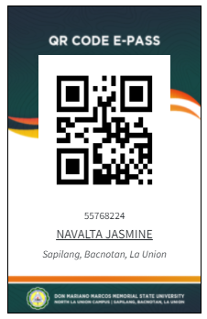
APPENDIX D

PRINT LOG SAMPLE

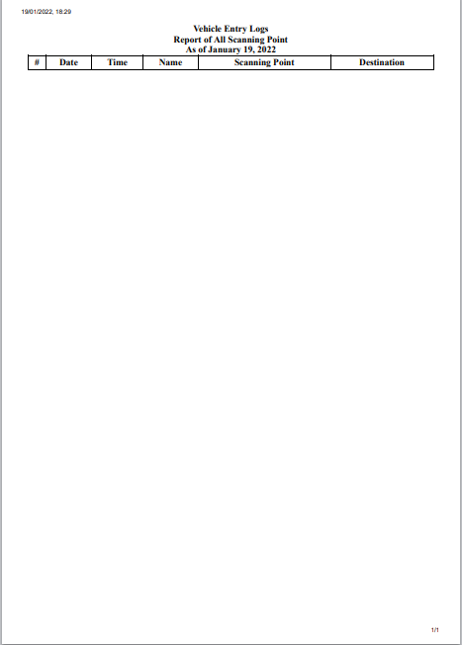

PLATES

ADMIN SYSTEM PAGE

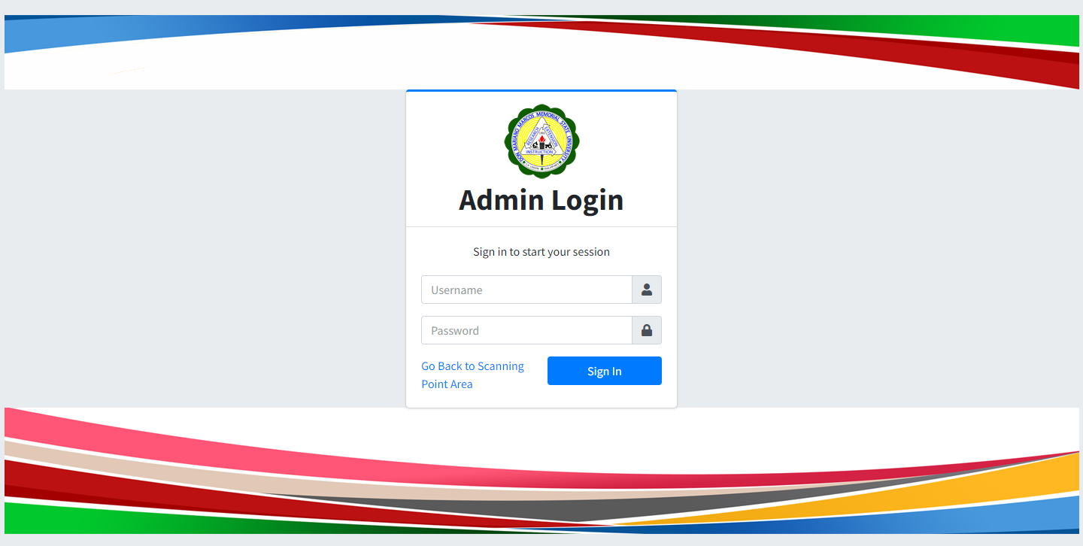

Admin Log-in
Input Username: admin
Password : **********

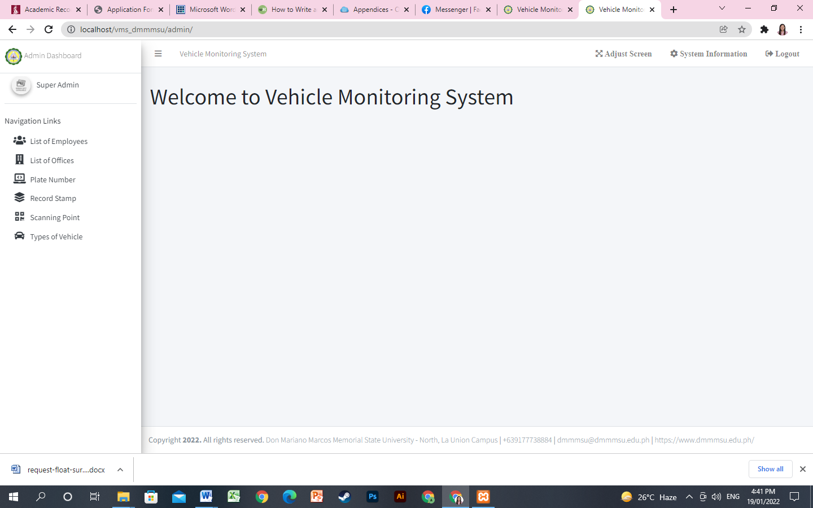
Welcome Page

System Tabs

On the top left corners of the system 6 Tabs can be seen these are:
List of Employees ,List of Offices, Plate Number, Record Stamp, Scanning Point, Types of Vehicles

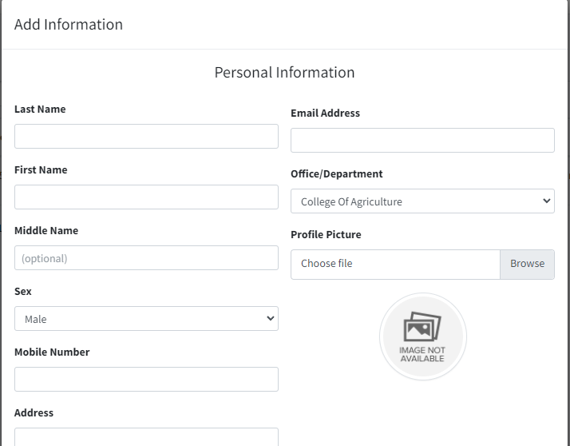
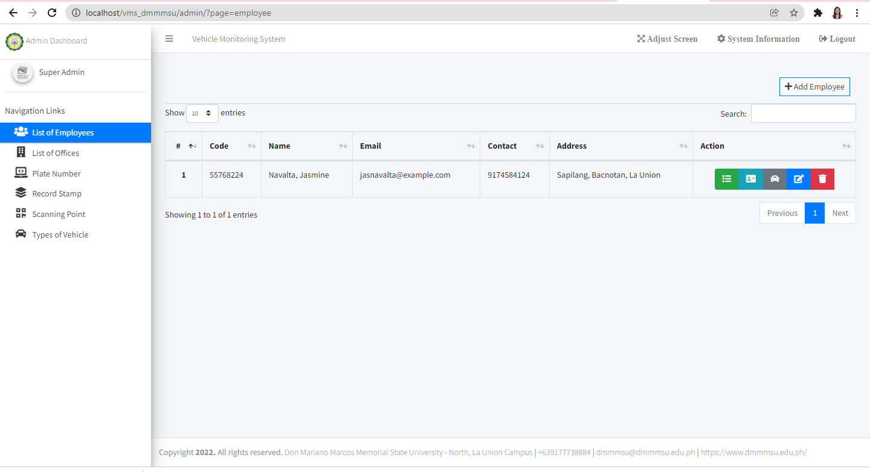

List of Employees Tab

This is the page where the admin can view registered employees and add employees.

The admin needs to input personal information of the employee such as: Last name, First Name, Middle Name, Sex/Gender, Mobile Number, Address, Email Address, Office/Department, Profile Picture.

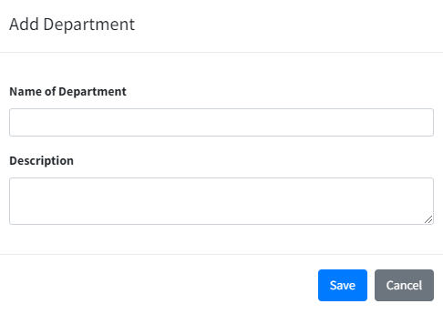
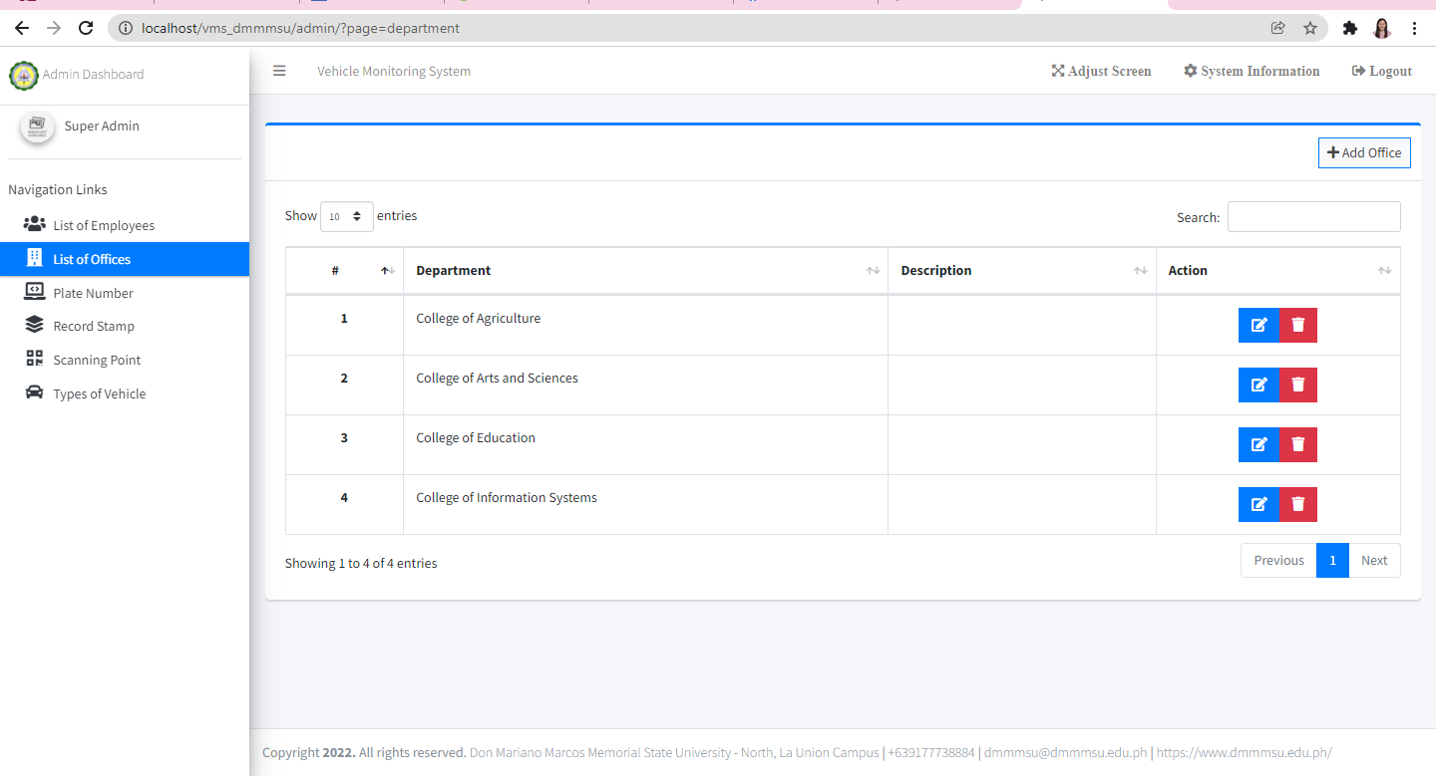

List of Offices Tab

This is where the admin can view, edit, delete or add records for destination places of the employees (Office/Department), that has a drop down menu on the add employee page.
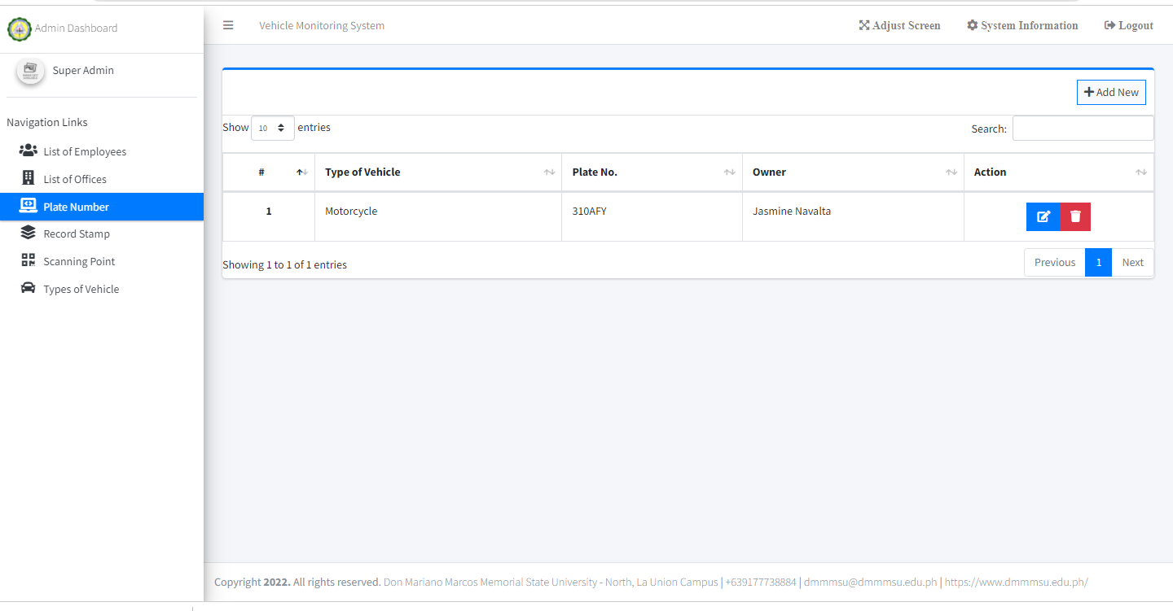

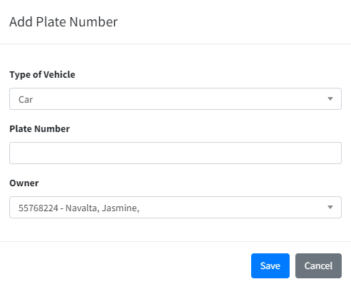

Plate Number Tab
This is where the admin can view, edit, delete or add records of vehicle plate numbers for the registered employees.

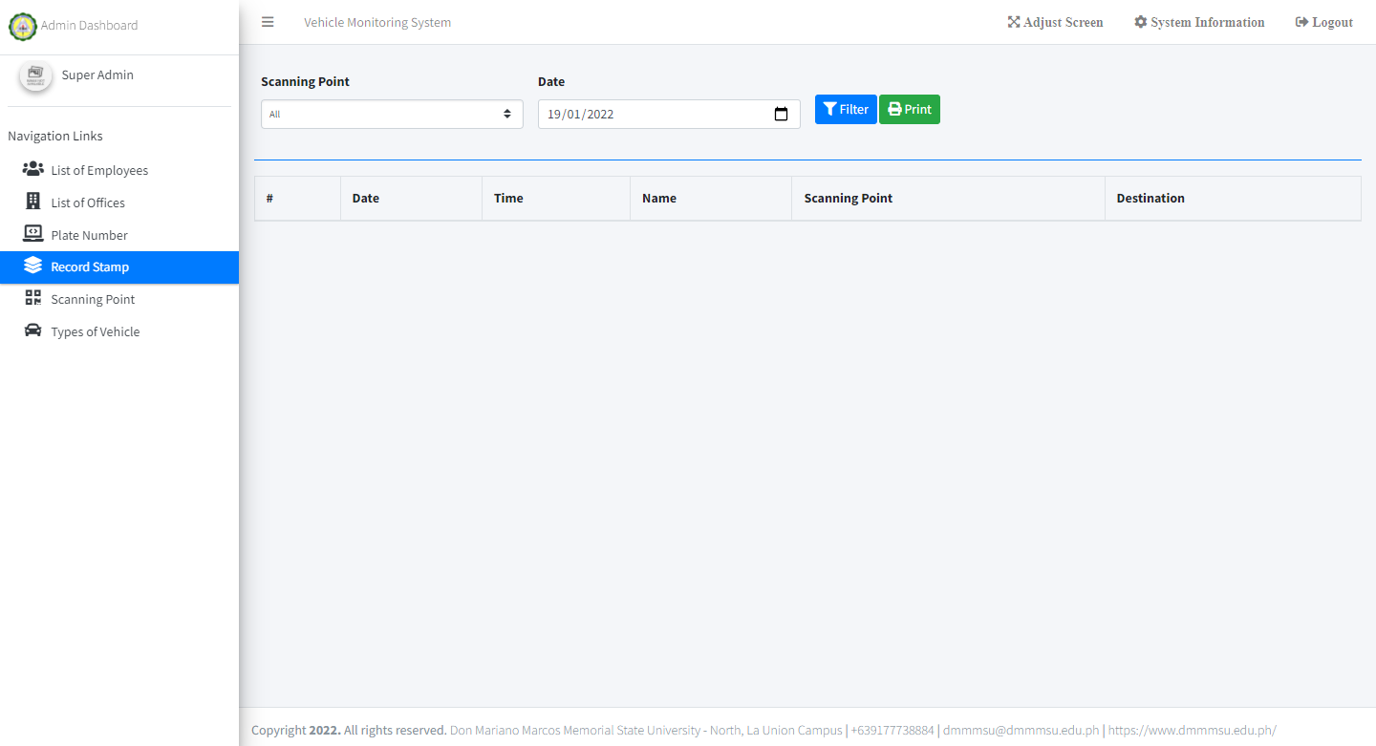

Record Stamp Tab
This is where the admin can view and print logs, the system offer filtering of data by date and vehicle plate number.

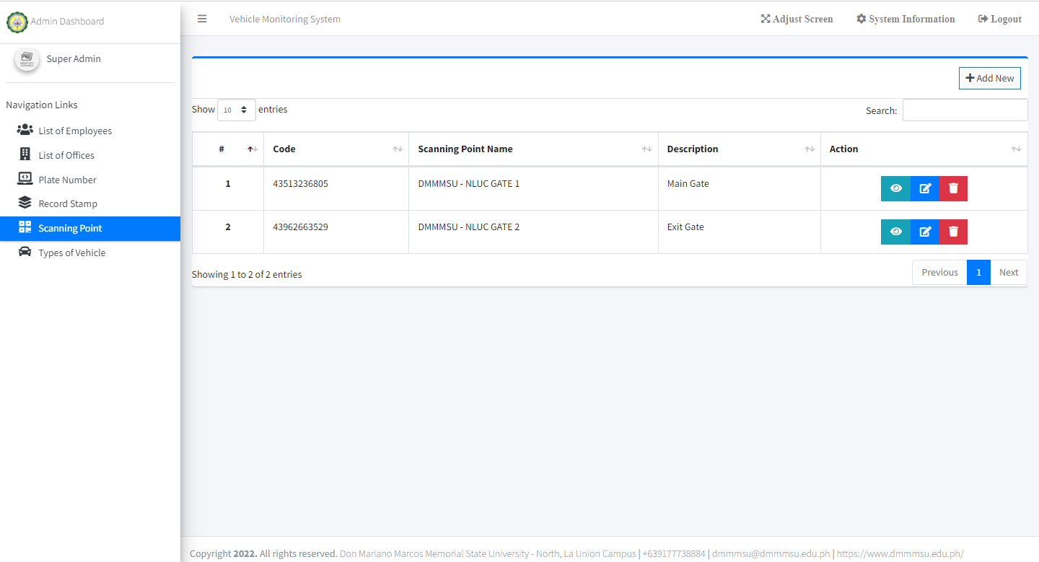

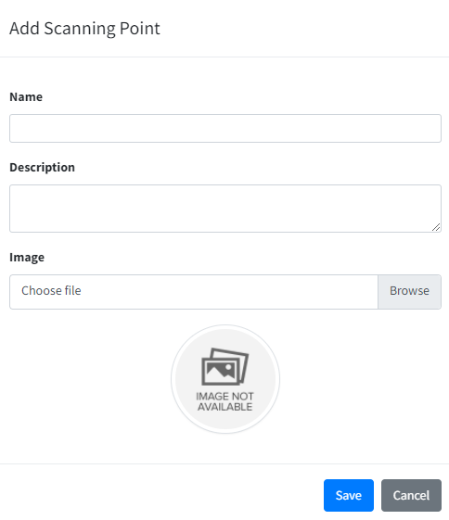

Scanning Point Tab
This is where the admin can view, edit, delete or add scanning points.

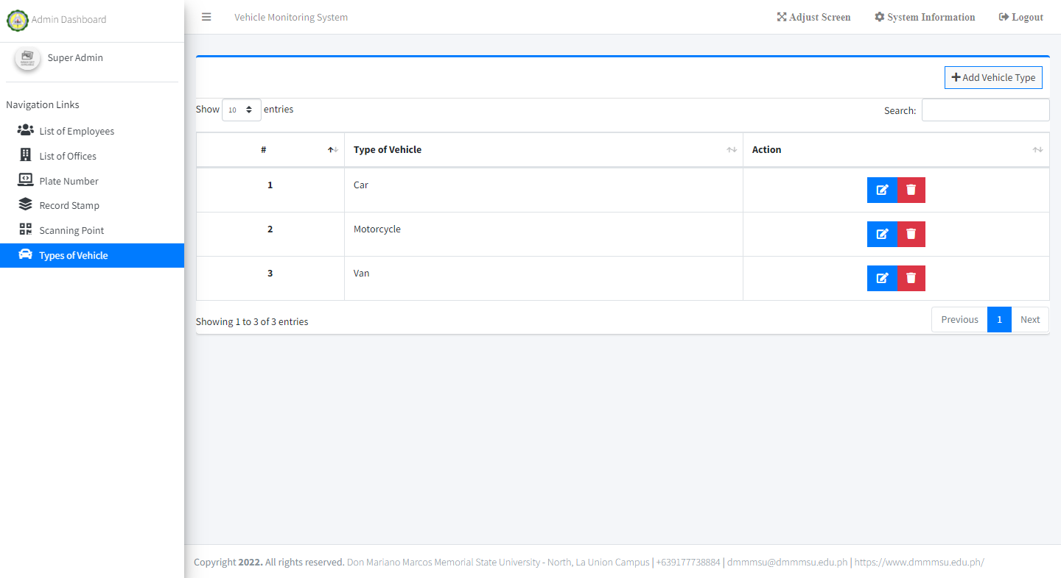

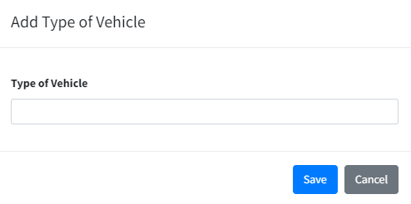

Types of Vehicle Tab
This is where the admin can view, edit, delete or add vehicle types.

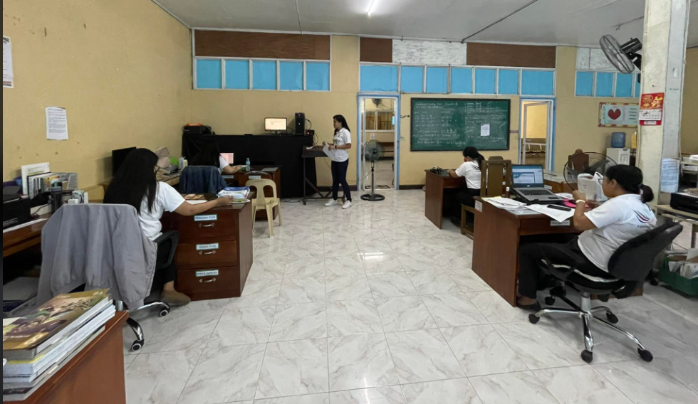
The developer presenting the system for evaluation (Employee with Vehicles)

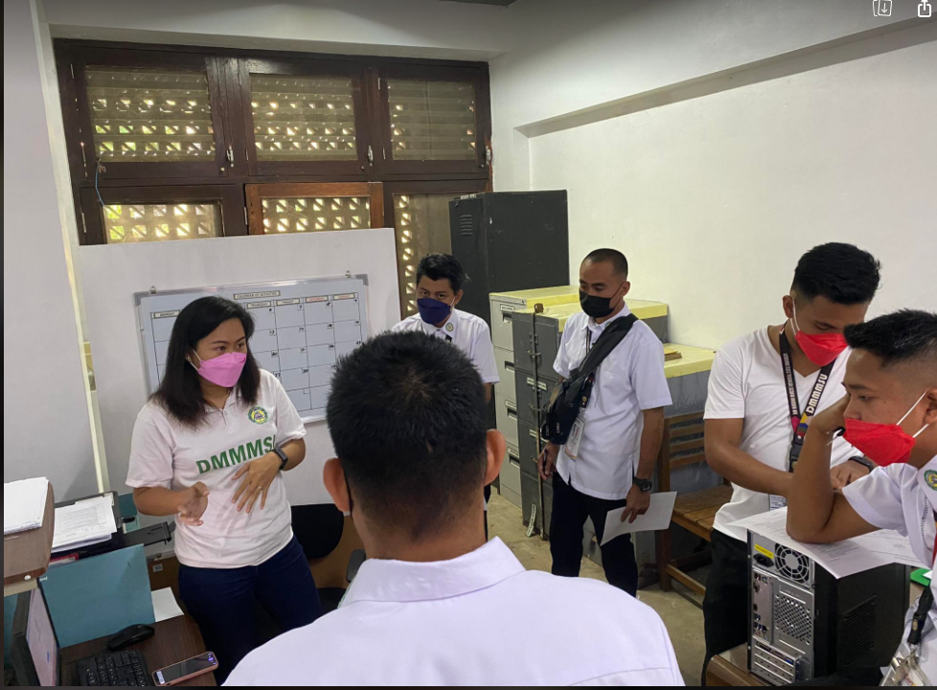
The developer presenting the system for evaluation (Security Officers)

